**AUTO BLOCKING AND HISTORY DELETION MESSAGING APP**

**CHOW ZI XUAN**

**A project report submitted in partial fulfillment of the**

**requirements for the award of Bachelor of Science**

**(Hons.) Software Engineering**

**Lee Kong Chian Faculty of Engineering and Science**

**Universiti Tunku Abdul Rahman**

**May 2017**

LIST OF TABLES

|  |  |  |
| --- | --- | --- |
| **TABLE** | **TITLE** | **PAGE** |
| Table 2.3.1.1 | Comparison between Java and Kotlin | 15 |
| Table 2.3.2.1 | Advantages and Disadvantages of Java and Kotlin | 16 |
| Table 5.1 | Testing stages | 46 |
| Table 5.2 | Content Testing for App | 47 |
| Table 5.3 | Content Testing for App | 47 |
| Table 5.4 | Interface Testing for App | 48 |
| Table 5.5 | Interface Testing for App | 48 |
| Table 5.6 | Interface Testing for App | 49 |
| Table 5.7 | Component Testing for App | 50 |
| Table 5.8 | Component Testing for App | 51 |
| Table 5.9 | Component Testing for App | 52 |
| Table 5.10 | Configuration Testing for App | 53 |
| Table 5.11 | Performance Testing for App | 54 |
| Table 5.12 | Security Testing for App | 55 |

LIST OF FIGURES

|  |  |  |
| --- | --- | --- |
| **FIGURE** | **TITLE** | **PAGE** |
| Figure 1.5.1 | The development cycle of Lean Methodology | 10 |
| Figure 2.2.1 | The process of Android devices receives push notification from GCM Cloud Connection Server | 13 |
| Figure 2.2.2 | Process of push notification of Android Devices | 14 |
| Figure 2.4.1 | Example of Chat Room using Socket IO (Enter Nickname) | 17 |
| Figure 2.4.2 | Example of Chat Room using Socket IO (Chatting) | 18 |
| Figure 2.5.1 | 20 iOS app with different category | 19 |
| Figure 2.5.2 | Category of user complaint | 20 |
| Figure 3.1.1 | A prototype of auto blocking profile | 22 |
| Figure 3.1.2 | A prototype of message deletion setting | 23 |
| Figure 3.2.1 | The development cycle of Lean Methodology  (Diagram adapted from Ries, E. (2011) ',' New York: Crown Business.) | 24 |
| Figure 3.3.1 | Trello Board | 27 |
| Figure 3.3.2 | Trello Calendar | 28 |
| Figure 3.3.3 | Checklist of User Interface design | 29 |
| Figure 3.3.4 | Checklist of Develop a MVP | 30 |
| Figure 3.3.5 | Checklist of Building a Database | 31 |
| Figure 3.3.6 | Checklist of Add Features | 32 |
| Figure 3.3.7 | Checklist of Test Run of App | 33 |
| Figure 4.1.1 | Use-Case Diagram for messaging app | 36 |
| Figure 4.2.2 | Database structure from Firebase | 38 |
| Figure 4.2.3 | users’ database in Firebase | 38 |
| Figure 4.2.4 | notifications’ database in Firebase | 39 |
| Figure 4.2.5 | messages’ database in Firebase | 39 |
| Figure 4.2.6 | friends_list’s database in Firebase | 40 |
| Figure 4.2.7 | friends_request database in Firebase | 40 |
| Figure 4.2.8 | chat’s database in Firebase | 40 |
| Figure 4.2.9 | block_settings’ database in Firebase | 41 |
| Figure 4.3.1 | Class Diagram for User and Contacts | 42 |
| Figure 4.5.1 | Login Activity | 44 |
| Figure 4.5.2 | Chat Activity | 44 |
| Figure 4.5.3 | Notification Blocking Activity | 44 |
| Figure 4.5.4 | Message Deletion Activity | 44 |
| Figure 5.8.1 | Crashlytic bug reporting | 56 |
| Figure 6.1 | Interface of Auto Blocking and History Deletion | 57 |
| Figure 6.2 | Interface of Profile, Conversation, Register and Login | 58 |
| Figure 6.3.1.1 | Welcome Activity | 59 |
| Figure 6.3.1.2 | Register Activity | 59 |
| Figure 6.3.1.3 | Processing Registration | 59 |
| Figure 6.3.1.4 | Login Activity | 59 |
| Figure 6.3.1.5 | Login Process | 59 |
| Figure 6.3.1.6 | New user added in Firebase | 60 |
| Figure 6.3.2.1 | Send Friend Request | 61 |
| Figure 6.3.2.2 | Cancel Friend Request | 61 |
| Figure 6.3.2.3 | Accept/Decline Friend Request | 61 |
| Figure 6.3.2.4 | Unfriend | 61 |
| Figure 6.3.2.5 | Friend request is created in Firebase | 62 |
| Figure 6.3.3.1 | Friends Fragment | 63 |
| Figure 6.3.3.2 | Dialog Options | 63 |
| Figure 6.3.3.3 | Chat Activity | 63 |
| Figure 6.3.4.1 | Gorilla Fragment | 64 |
| Figure 6.3.4.2 | Message Deletion Activity | 64 |
| Figure 6.3.5.1 | Gorilla Fragment | 65 |
| Figure 6.3.5.2 | Instant Blocking Period | 65 |
| Figure 6.3.5.3 | Custom Blocking Period | 65 |
| Figure 6.3.5.4 | Set Start Time | 65 |
| Figure 6.3.5.5 | Set End Time | 65 |

LIST OF SYMBOLS / ABBREVIATIONS

App - Application

GCM – Google Cloud Messaging

JS – JavaScript

HTML – Hyper Text Markup Language

Activity – A fundamental building blocks of apps on the Android platform

# CHAPTER 1

## INTRODUCTION

### Introduction

Messaging applications or chat applications are instant messaging clients that allow messages to be sent and received between mobile devices or a computer. Text, photos, videos, and voice messages are used by the user to communicate with each other frequently.

Auto blocking and history deletion messaging app aims to deliver a new experience for the user. The app will be focusing on blocking the notification of the incoming messages and removing of older messages automatically. The purpose of creating this app is to help users to manage their own messages in a convenient way. Therefore, it will help user to spend less time to clear the trash of the phone, and it will help user to save a lot of times for other activities. It will also help the user that didn’t have the habit of removing messages frequently to free up more storage of the phone.

### Background of the problem

Auto blocking and history deletion messaging app is a mobile application to block the notification of incoming messages automatically and delete messages by following the schedule by the user. There are a few messaging apps in the market, but the auto blocking and message deletion features is implemented with limited option for the user.

Auto blocking features in WhatsApp, Messenger, and WeChat have limited option for the user to preset the auto blocking period. User has limited choice will lead to inconvenience when using the application. Majority of the users don’t care much about history deletion of their messaging app. It will consume up plenty of time to delete the message when the phone pop-out insufficient of storage alert to inform user to free up the space of the phone in order to reserve storage for incoming messages.

### Problem Statement

* Messages that keep in local storage will use up the spaces of the internal memory of a smartphone after a long-term usage of messaging apps. It will cause insufficient of phone storage and degrade the performance of the phone.
* Clearing or deleting “tonnes” of messages manually is consider as a waste of time. It’s a tedious process for a user to keep track and manage their history of messages manually.
* Users have difficulties in searching for important messages by scrolling up and down the screen and check it one by one.
* The auto blocking function is not highly customizable by the users currently. There are also limited ~~of~~ options for users to block incoming messages automatically based on their preferences.

### Project Objectives

The objective of the project is to develop a messaging app that aims to

* prevent excessive storage usage by deleting messages automatically in order to free up the internal storage of the phone.
* save user’s time spent in deleting messages manually by providing customizable options to perform the deletion of messages automatically.
* ease the user to search for important messages by deleting unwanted messages automatically.
* stop disruption from certain people by blocking notification of incoming messages based on the user’s customizations.

### Proposed Approach

The methodology that is going to implement in this project is Lean Methodology. The core idea of this methodology is to maximize in user value while minimizing waste. In other words, we can say that this methodology is creating more value and benefit for user with lesser resources. In this project, the Build-Measure-Learn principle (one of the central principle of Lean methodology) will be used. The development cycle of the methodology is a Build-Measure-Learn loop in order to improve the quality and requirement of the product.

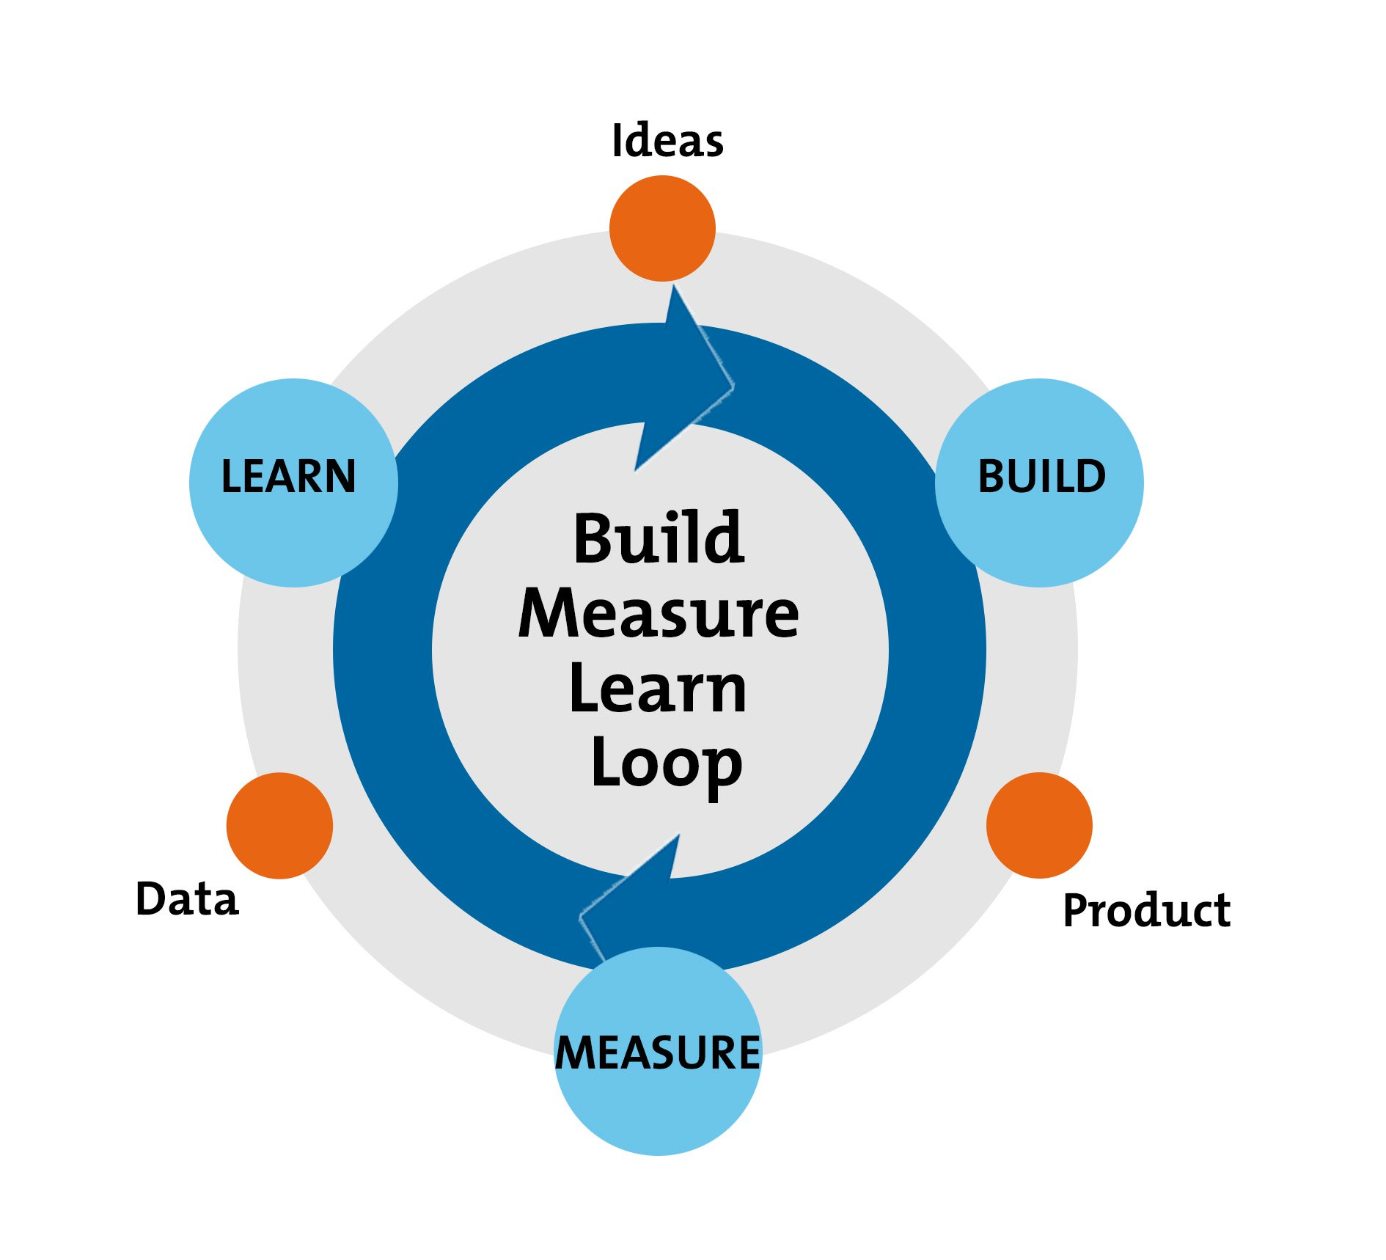

**Figure 1.5.1 The development cycle of Lean Methodology**

**(Diagram adapted from Ries, E. (2011) '**[**The Lean Startup**](https://www.amazon.com/Lean-Startup-Innovation-Successful-Businesses-ebook/dp/B004J4XGN6/)**,' New York: Crown Business.)**

Before the Build-Measure-Learn cycle, the project is better to start with a planning stage. First, develop a hypothesis that will happen during the project. The hypothesis can focus on the user ideas and the features of the product. After that, in the “Build” phase, create a Minimum Viable Product(MVP), it is a product that can work to fulfil the basic requirements to test out the hypothesis that create during the planning stage. During the “Measure” phase, the result in the “Build” phase is being analyse whether the idea is sufficient enough to continue the development of the product. It is good to question that whether the result is meeting the requirement of the product.

Lastly, the decision making will happen in the “Learn” phase. There are 2 ways to forward, it is “Persevere” and “Pivot”. We choose “Persevere” when the hypothesis is correct and repeat the development cycle loop to improve and refine the idea. If “Pivot” is chosen, that means the hypothesis is proven to wrong, but we can gain valuable knowledge from the mistakes. Therefore, the loop is going to reset with using the knowledge that we learnt in the previous hypothesis.

**Summary of the methodology:**

**Step 1**: Planning of the project followed by a formal hypothesis

**Step 2**: Build a Minimum Viable Product (MVP) and test it.

**Step 3**: Analyse the result against the hypothesis to decide whether the product can be continued to develop to fulfil the business needs.

**Step 4**: Learn from the result on step 3, and decide whether to persevere or pivot.

### Scope of the Project

The auto blocking and history deletion messaging app will include the basic features of a messaging app, i.e. the function of send and receive messages includes images and short videos. The application will provide a login interface for users to have their own identity. Moreover, the function of blocking the notification of incoming messages and deleting the previous messages will be implemented in the application. The application is able to mark important messages and customize messages deletion automatically. The messages being marked will be exempted from deleting. Furthermore, the app will have a filter to display important messages only. Backup and restore chat history function will also be implemented.

# CHAPTER 2

## LITERATURE REVIEW

### Comparison of Texting, Messaging, and Online Chatting

The term of texting, messaging, and chatting has the meaning of two-way communication between 2 individuals or more. But, the three communication options have their own features and characteristics to best fit the requirement. The aim of the project is to develop a messaging app with certain features. Therefore, a clear picture to term of “Messaging” is important. The table below provides the comparison of the three types of communication.

|  |  |  |  |
| --- | --- | --- | --- |
|  | **Texting (SMS)** | **Messaging** | **Online Chatting** |
| Methods of obtaining the service | Pre-installed on the mobile phone before the release of smartphone. Available in mobile app or web-based after the smartphone was created | Comes with mobile app or web-based | Available in a form of website or a plugin |
| Example of usage in real world | Sending text messages via cellular network with the mobile service provider without Internet Service | Messaging apps like WhatsApp, Facebook Messenger, and WeChat that can get instant reply with mobile data or WiFi service. | Customer service of a website |
| Limitation of message size | 160 characters | Unlimited | Unlimited |
| Content support | Text | Text, Image, Video | Text |
| Platform support | Pre-installed in phone by phone manufacturer before the release smartphone .  Cross-platform in the form of mobile application in the app market of smartphone | Cross-platform  (mobile phone, web browser) | Web browser |

**Table 2.1.1 Comparison of Texting, Messaging and Online Chatting**

### 2.2 Push Notification

Nowadays, push notification is an important feature in an app to engage the app’s users. It keeps users to get the latest information and notifications by the apps with running in the background of the phone. Push notification ensures that users able to read messages by pop-out notification while the app is running in background or is suspended. Majority of Android devices are based on Google Cloud Messaging (GCM).

GCM is a service by Google company that transmits information from a server to Android devices which connected to Google Play Service. GCM can carry small size of messages with data payloads not exceeding 4KB (Abrosimova, n.d.). Figure 2.2.1 indicates how mobile devices get push notification.

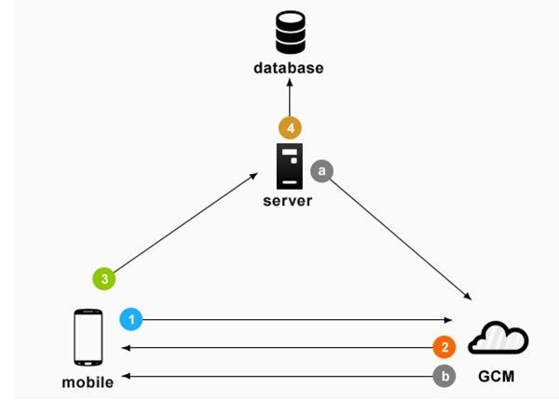

**Figure 2.2.1 The process of Android devices receive push notification from GCM Cloud Connection Server**

(Abrosimova, n.d.)

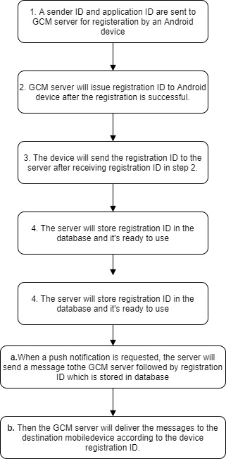

**Figure 2.2.2 Process of push notification of Android Devices**

### 2.3 Java and Kotlin Programming Language

Having a basic of Java programming language knowledge is the prerequisite for a software developer to work with Android Studio. With using Java, Android Studio is able to create interactive UIs and design simple views for each activity of the mobile app.

#### Comparison between Java and Kotlin

Java and Kotlin are the current programming language that use to develop Android application. Each of the programming language has its own priority for any business. Table 2.3.1.1 is a comparison between Java and Kotlin.

|  |  |  |
| --- | --- | --- |
|  | **Java** | **Kotlin** |
| **Author** | James Gosling | Andrey Breslav |
| **Type** | Object-Oriented | Object-Oriented |
| **Learning curve** | Low | Low |
| **Code Size** | Have to write more code than Kotlin | 30-40% less code as compared to Java |
| **Rendering** | Client Side | Client Side |
| **App Size** | Have less size as compare to Kotlin. Gradle build time for Java is faster as compared to Kotlin | Used up more space as because contains of Kotlin as well as Java libraries. |
| **Checked Exception** | Yes | No |
| **Use of semicolon** | It is a must to write semicolon to terminate a line of code. | It is optional to write semicolon in the end of statements. |

**Table 2.3.1.1 Comparison between Java and Kotlin**

#### Advantages and Disadvantages of Java and Kotlin

|  |  |  |
| --- | --- | --- |
| **Programming Language** | Advantages | Disadvantages |
| Java | * Faster Gradle build time * More open source libraries and frameworks * More reliable and still have updates since 1995 until now | * It is not null safe by default * Consume more memory space * Vulnerable to security threats |
| Kotlin | * It is null safe by default * Easy to learn * Easy to adopt from Java | * Slower Gradle build time * No checked exception * The need for Java interoperability has forced some limitations |

**Table 2.3.2.1 Advantages and Disadvantages of Java and Kotlin**

### Messaging app with React Native and Socket.io

Socket.io is a framework that creates network socket for the server and client. It’s a real-time engine that supports instant messaging and chat with just a few lines of code. It works fine with the React Native. Socket.io supports communication between single client and multi clients once the socket is established and the users can speak freely without delay and it is faster that a HTTP request. Socket.io can create a chat group for a certain number of users in the same port. Figure 2.4.1 is an example of chat room that requires user nickname to enter a chat room. Figure 2.4.2 is an example of conversation between 2 users.

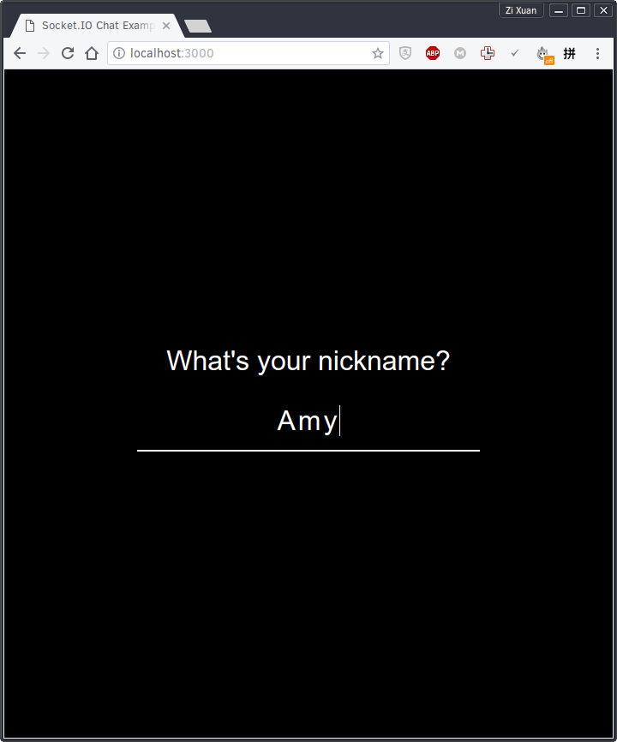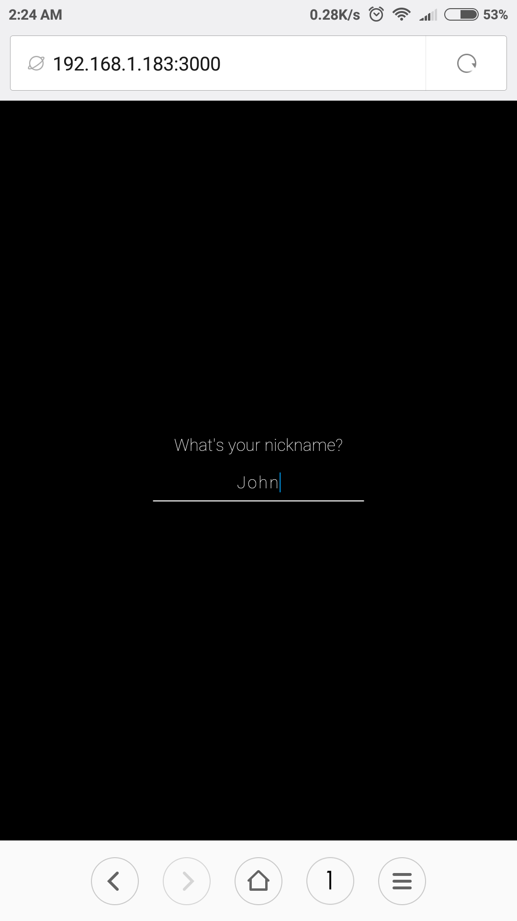

**Figure 2.4.1 Example of Chat Room using Socket IO (Enter Nickname)**

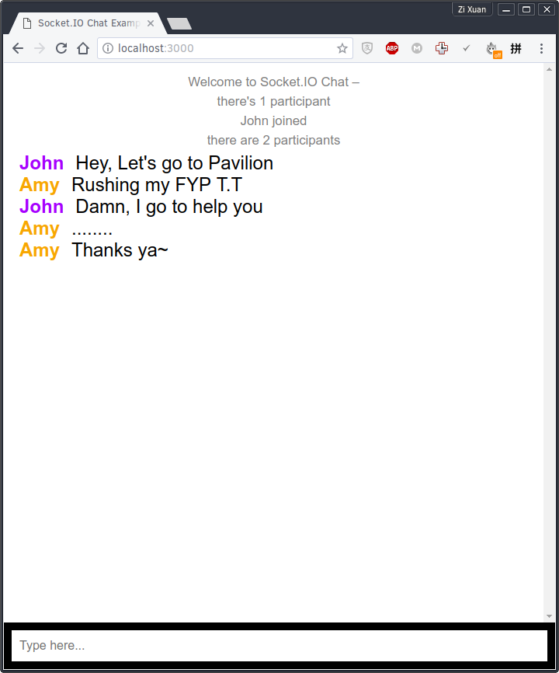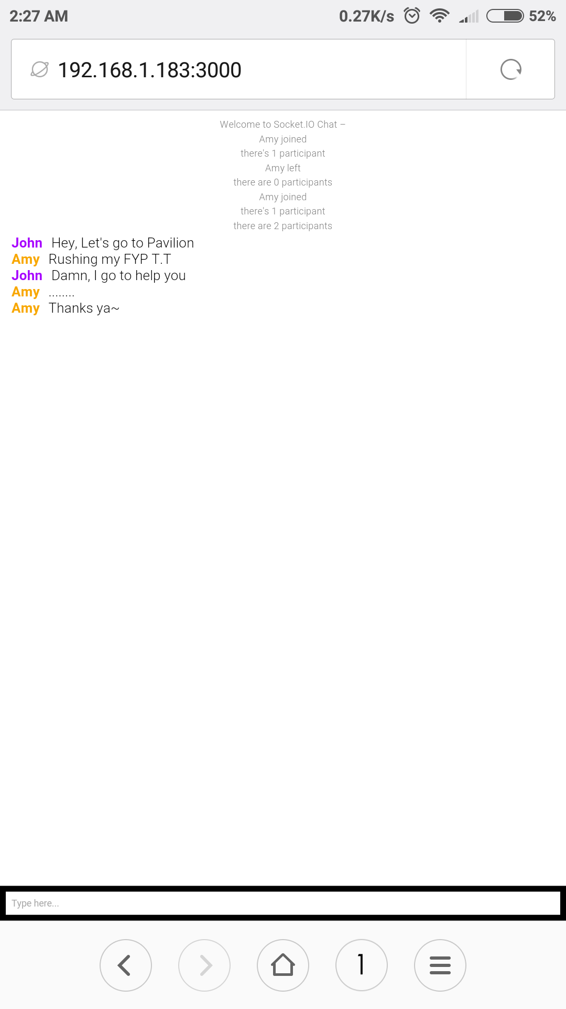

**Figure 2.4.2 Example of Chat Room using Socket IO (Chatting)**

### 2.5 What do mobile app users complain?

The quality of app has been the main concern for the app company currently. A research is carried out to study the feedback from users of 20 iOS apps and Figure 2.5.1 shows the statistics of the studies. The 20 iOS apps are from different category.

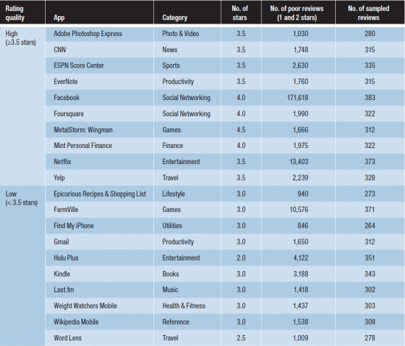

**Figure 2.5.1 20 iOS app with different category**

**(Khalid, Sahihab, Nagappan and Hassan, 2014)**

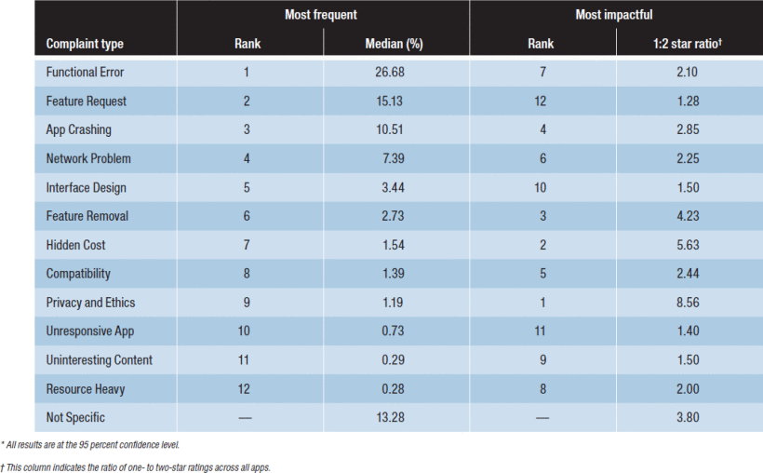According to the research, there are 12 types of most frequent complaint by the mobile app users. The first three columns of Figure 2.5.2 show the type of most complaint issues by the users. Functional Error is ranked on the top column which indicates the most serious problem that encountered by the users. The examples of functional error are location identification issues and authentication problems. The feature request complaint is ranked in number 2. The most requests feature by the users were app specific. But, there are 6.12 percent of the request were for better notification support.(Khalid, Sahihab, Nagappan and Hassan, 2014). App crashing is also one of the critical complaints by the mobile app user which can affect the user experience and it indicates the stability of a mobile apps.

**Figure 2.5.2 Category of user complaint**

**(Khalid, Sahihab, Nagappan and Hassan, 2014)**

# CHAPTER 3

## METHODOLOGY AND WORK PLAN

### Description of the project

The goal of the project is to develop a messaging app which has the auto blocking and history deletion features. The messaging app will also work like a normal messaging app which can send and receive text, image and video messages within 2 or more individuals.

One of the main features of auto blocking in the messaging app is to block incoming notifications and retain messages from the sender. Comparing to other messaging in the app market, there are more blocking options in the app. It will let user to customize the auto blocking period and it can be saved into a profile for future use. Besides that, users are able to customize the history deletion automatically, the messages that deleted automatically will uploaded to the cloud server as a backup. The older messages can be obtained when needed and it will to free up the local storage of the phone.

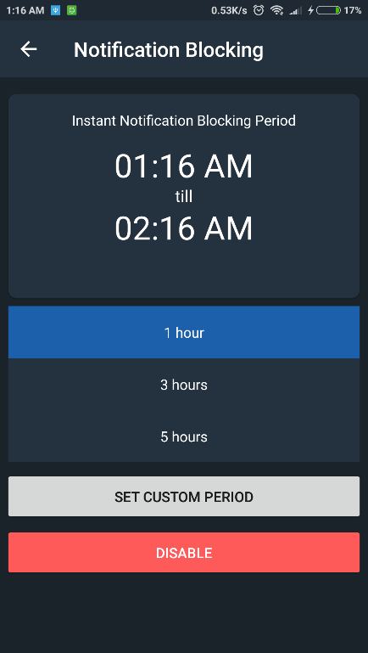

**Figure 3.1.1 A prototype of auto blocking profile**

Figure 3.1.1 is a prototype of auto blocking profile that can be customized by users. When the switch is turn on, the auto blocking period will start. The notification of the messaging app will auto mute but the messages will still receive by the phone. The auto blocking function will not apply to the whole app, users can tap in the and customize blocking profile and block specific contact.

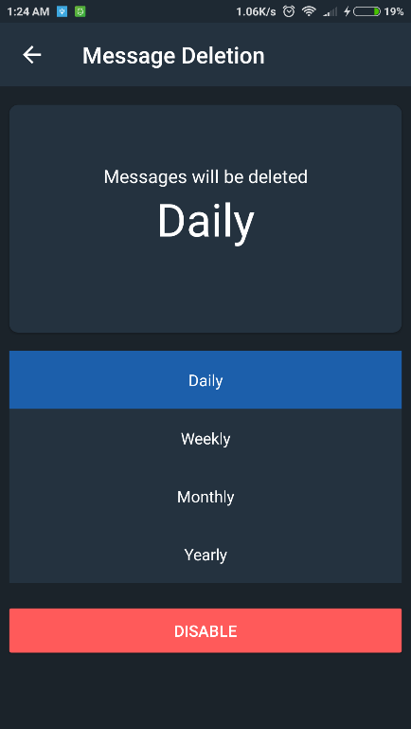

**Figure 3.1.2 A prototype of message deletion setting**

Figure 3.1.2 is a prototype of message deletion setting that allows users to customize their message deletion options. Recycle bin is a feature to archive deleted messages, users are able to restore deleted messages from recycle bin. Chat History Backup allows users to back up their previous messages to cloud server after the messages was removes permanently. Users can set the date to delete the messages every month or user can pick more specific date and time to delete the message automatically.

### Methodology Adopted

The methodology that adopted in this project is Lean Methodology. The main concern of Lean Methodology is suitable for mobile app development which maximize users’ value and minimize the waste of resources. The development cycle of the Lean Methodology is Build, Measure, and Learn. It is an effective way to build a mobile application that fulfil the requirements of users and speed up the development period. This method let the developer learns from the mistakes made during the development and help the developer to improve the product to match the hypothesis that made during the planning phase.



**Figure 3.2.1 The development cycle of Lean Methodology**

**(Diagram adapted from Ries, E. (2011) '**[**The Lean Startup**](https://www.amazon.com/Lean-Startup-Innovation-Successful-Businesses-ebook/dp/B004J4XGN6/)**,' New York: Crown Business.)**

**Summary of the Build-Measure-Learn Loop**

**Planning**

A planning of the project is needed before the process of development is going into the Build-Measure-Learn development cycle. The planning of the project must be followed by a formal hypothesis that made by the developer.

A messaging app will be developed in this project, the messaging app must planned with a few of hypothesis such as the messaging is able to send and receive messages with notifications. An auto blocking feature~~s~~ with customization period is needed. Message deletion must be able to be customized by users and could delete messages automatically based on setting.

**Build**

Build a Minimum Viable Product(MVP) based on the hypothesis that made during the planning phase. It must fulfil the basic requirements of the product before releasing for any testing.

the messaging app in this project must have at least a working function of send and receive messages without any bugs. It must also support text, image, and video. The auto blocking feature must at least can block all incoming notification after the setting is enabled by users. It can at least delete messages automatically after the customization of setting is done. Make sure the basic functions of the app can work fine before going to the next phase of development.

**Measure**

In this phase, the product is being analyse whether the result of the product is similar or diverge with the hypothesis. If yes, it is suitable to continue to fulfil the users’ needs.

The auto blocking feature in the app doesn’t work like the hypothesis that made by the developer and it needs to block message manually, which means it failed to achieve the.

**Learn**

There are two ways to choose to bring the product to the next level. “Persevere” is chosen when the hypothesis is correct and fits the idea of product. Then, the product can undergo the cycle of Build-Measure-Learn again to improve or add-on some new features to the product. If the product doesn’t fit the hypothesis, “pivot” is chosen, which means the hypothesis is proven to be wrong, but it doesn’t matter, as long as the developer will gain valuable knowledge from the mistake that they made.

When the app basic functions fulfil the hypothesis, we choose “persevere” to go a step further to improve the basic functions to make it more reliable. If the function of the product is far away from expectation, choose “pivot” to find out how to deal with the mistakes or what is the core problem that makes the product failed to achieve the requirements.

### Work Plan

The project work plan is keep track with Trello, which is suitable for a small size or individual project. Figure 3.3.1 is Trello board that lists out the work plan to fulfil in Project 2. The work plan is divided into 3 lists which are To Do, Doing, and Done. The deadline of each task is set to prevent any of the task left out from the project.

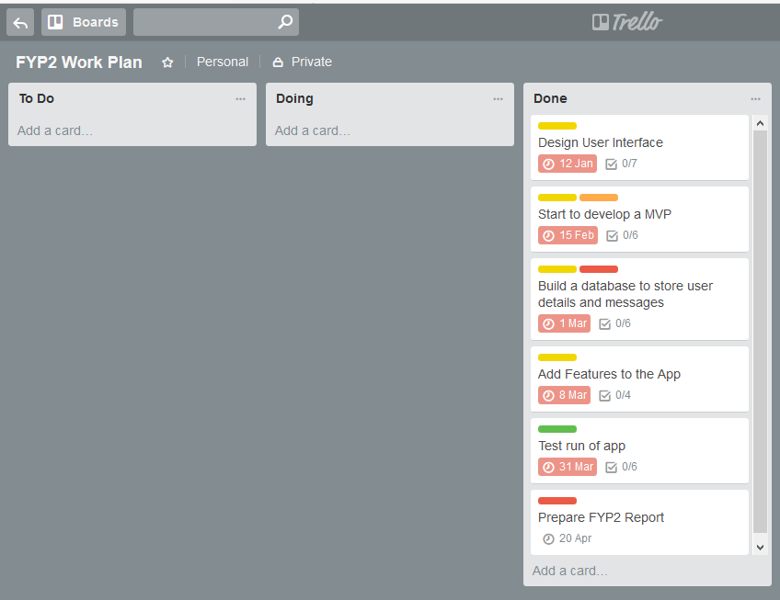

**Figure 3.3.1 Trello Board**

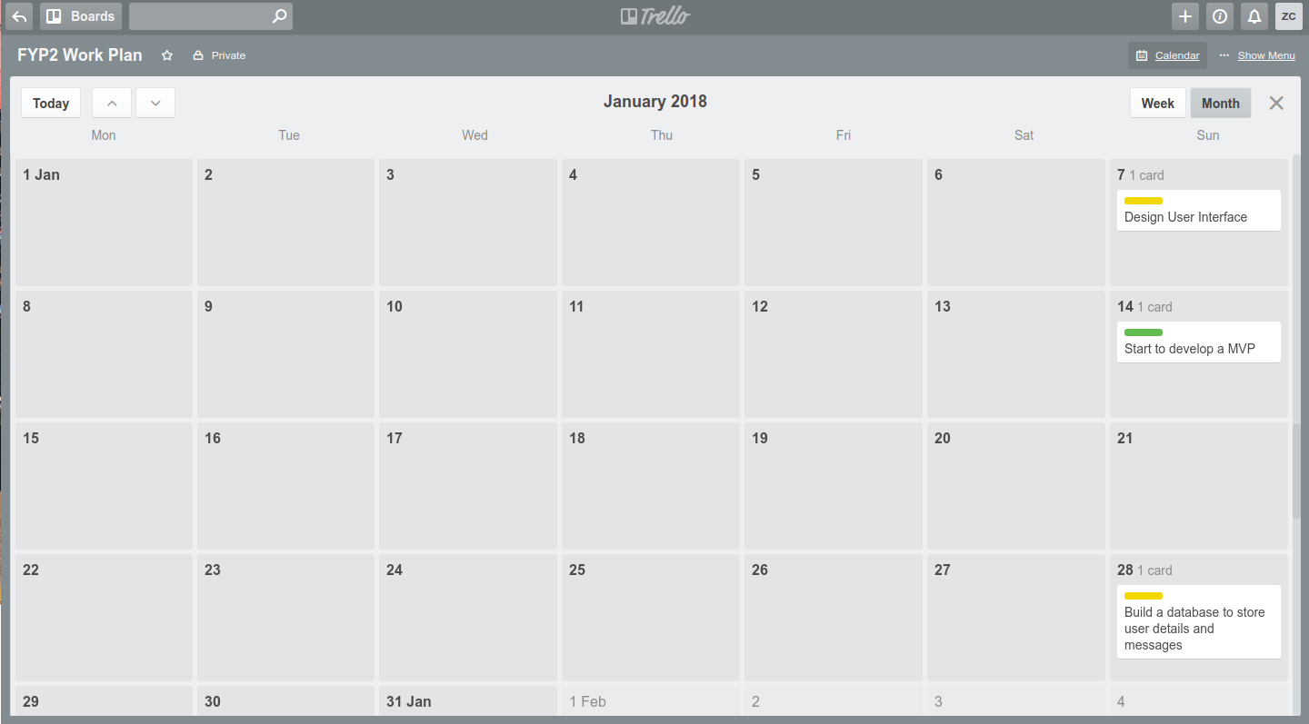Trello Calendar is able to display the deadline of each task clearly Different colour of label indicates different level of importance.

**Figure 3.3.2 Trello Calendar**

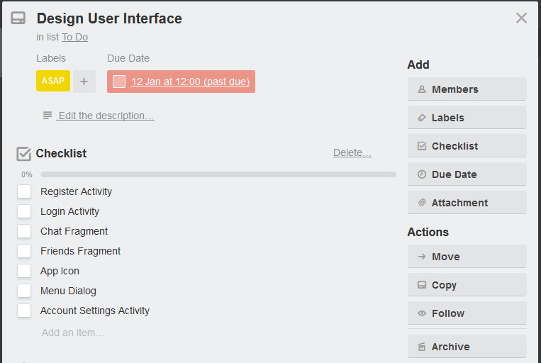

**Figure 3.3.3 Checklist of User Interface design**

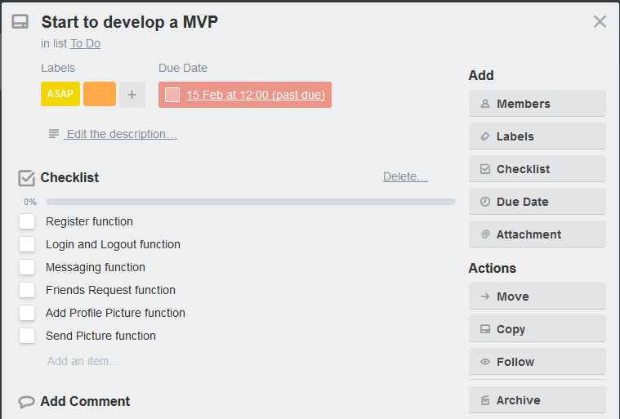

**Figure 3.3.4 Checklist of Develop a MVP**

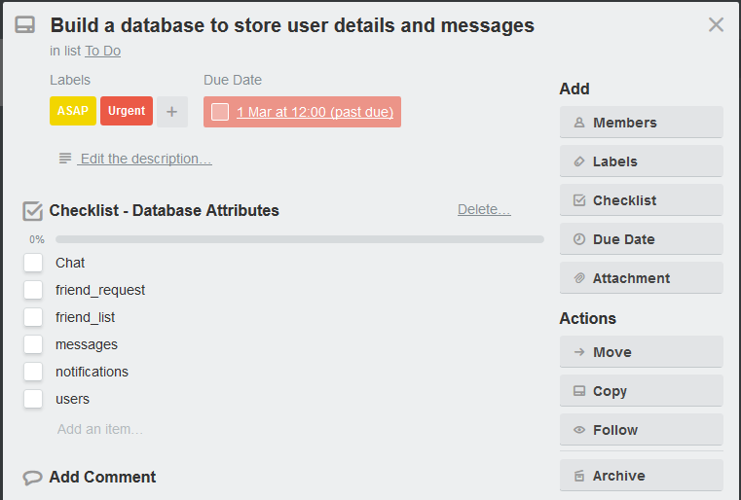

**Figure 3.3.5 Checklist of Building a Database**

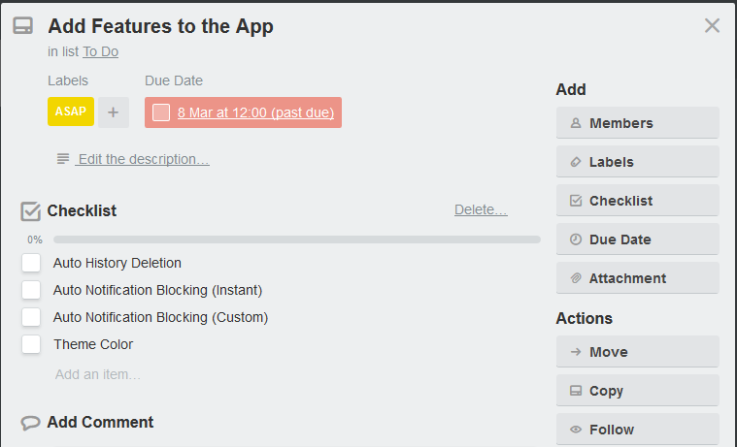

**Figure 3.3.6 Checklist of Add Features**

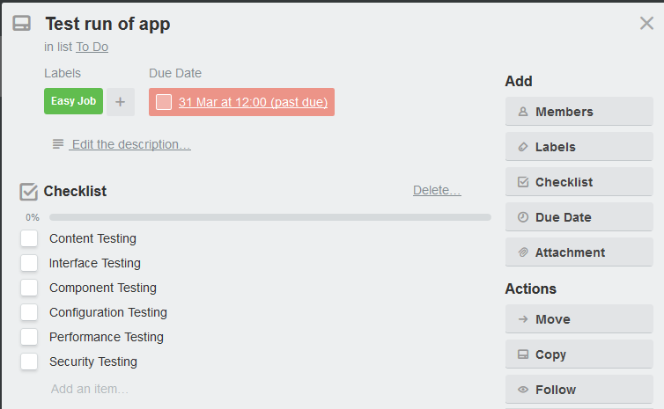

**Figure 3.3.7 Checklist of Test Run of App**

### 3.4 Development tools

**Android Studio**

It is used to develop the front-end of the mobile app, and it could also install plugin like Firebase and Crashlytics to for database implementation and bug reporting respectively.

**Sublime**

A text editor that can support the develop of React JS syntax and can code faster with the auto-complete function of the text editor. It has a nice folder and file management for a project. Using the plugin of Babel JS, the syntax of React JS can be shown clearly in its own colour tone.

**MockingBot**

It is a prototype tools that is easy to use to sketch the user interface of the mobile app. It includes the elements of iOS and Android which can produce a working prototype. The prototype can save and test run on a web browser on PC or a phone.

**BitBucket**

A version control repository that support Git. It can store project in private state for free which can access by the author only. Bitbucket can support up to 5 members in a team and manage the role of the 5 member to read, write or read and write permission of the repository.

**Android Virtual Device**

To test run the result of the app development before shipping out the workable mobile application. The Android Virtual Device comes with Android 6.0 Marshmallow which can support the development of React Native.

**Terminal**

To view the error when the app crash during the development with using React Native. It is mandatory to use it to run React Native. Terminal is available in macOS or Linux, it’s a powerful tool to manage a computer without using the Graphical User Interface.

**Firebase**

A NoSQL database that provides by Google and it is performed well with Android Studio. In this project, it is used as a real-time database for the messaging purpose. Besides that, it also able to store user’s data.

**Crashlytics**

It is one of the product from Fabric to monitor app crashing of the mobile app on a device. It can generate a bug report to the developer when there is an app crash from the client side. In addition, it can also monitor the growth of the app.

# CHAPTER 4

## PROJECT INITIAL SPECIFICATION

### Use Case Diagram

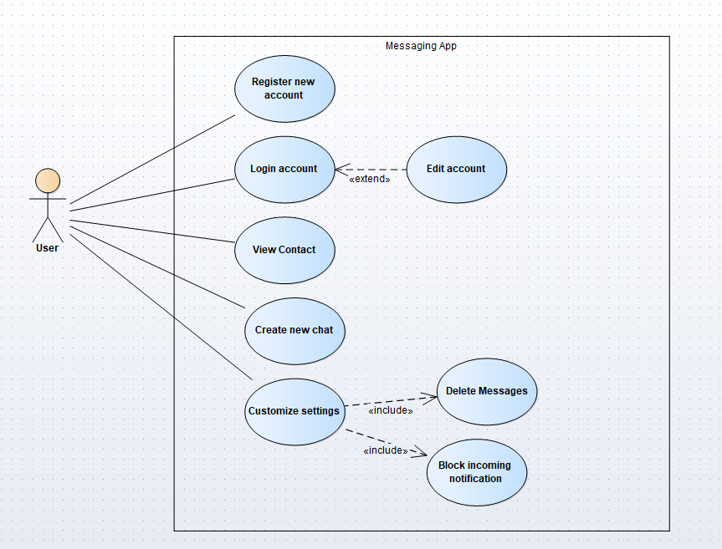

**Figure 4.1.1 Use-Case Diagram for messaging app**

#### 4.1.1 Use-Case Diagram Description

User is the person that uses the messaging app and the use-case indicates the actions that can be done by the user. New user must register an account before login to the messaging app. After login to the messaging app, the user will be able to edit account information such as name, age, birth date, etc. User can view contacts that they added. User can create new chat include group chat. User can customize setting like auto blocking incoming notification and history deletion.

### Database Structure

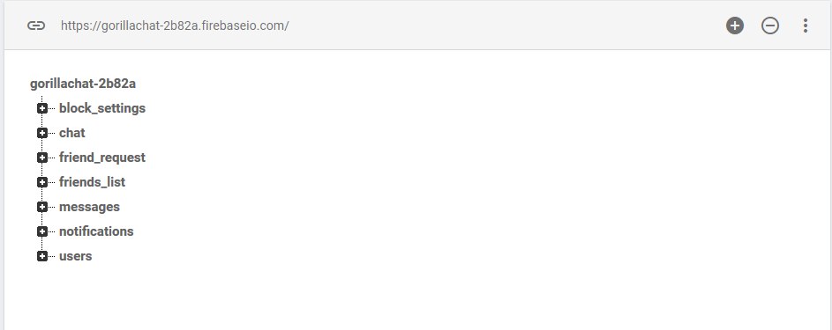**Figure 4.2.2 Database structure from Firebase**

Figure 4.2.2 is a database structure of the messaging app, it is store in NoSQL database model and it is perform well for real-time database service. “gorillachat-2b82a” is the parents of the block_settings, chat, friend_request, friends_list, messages, notifications, and users.

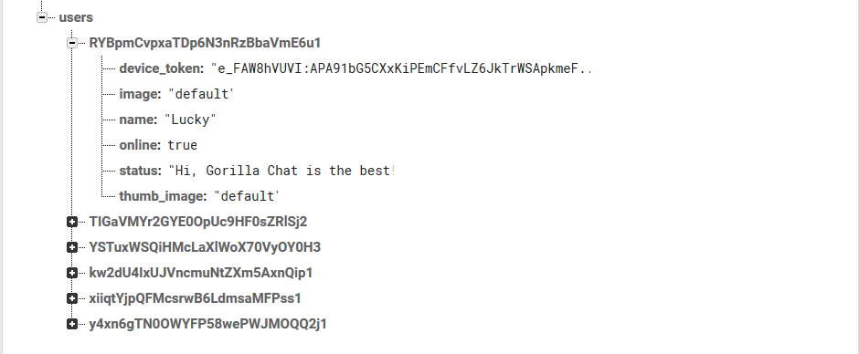**Figure 4.2.3 users’ database in Firebase**

The structure of users’ database

|-users

|-user_id

|- device_token

|- image

|- name

|- online

|- status

|- thumb_image

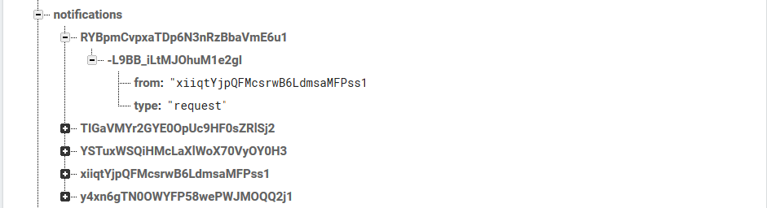

**Figure 4.2.4 notifications’ database in Firebase**

The structure of notifications’ database

|-notificataios

|- sender_id

|- receiver_id

|- from

|- type

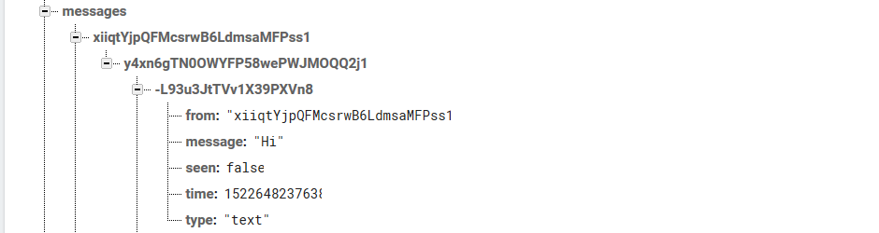

**Figure 4.2.5 messages’ database in Firebase**

The structure of notifications’ database

|-notificataios

|- sender_id

|- receiver_id

|- push_id

|- from

|- message

|- seen

|- time

|- type

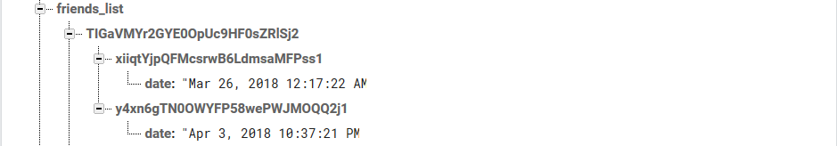

**Figure 4.2.6 friends_list’s database in Firebase**

The structure of friends_list’s database

|-notificataios

|- sender_id

|- receiver_id

|- date

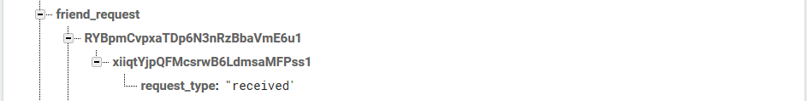

**Figure 4.2.7 friends_request’s database in Firebase**

The structure of friends_list’s database

|- friend_request

|- sender_id

|- receiver_id

|- request_type

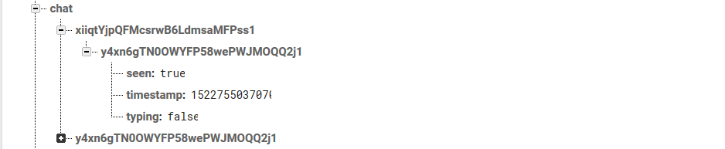

**Figure 4.2.8 chat’s database in Firebase**

The structure of chat’s database

|- chat

|- sender_id

|- receiver_id

|- seen

|- timestamp

|- typing

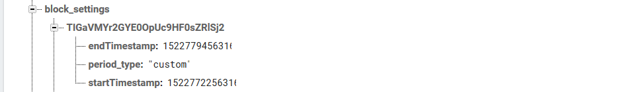

**Figure 4.2.9 block_settings’ database in Firebase**

The structure of block_settings’database

|- block_settings’

|- user_id

|- endTimestamp

|- period_type

|- startTimestamp

### Class Diagram

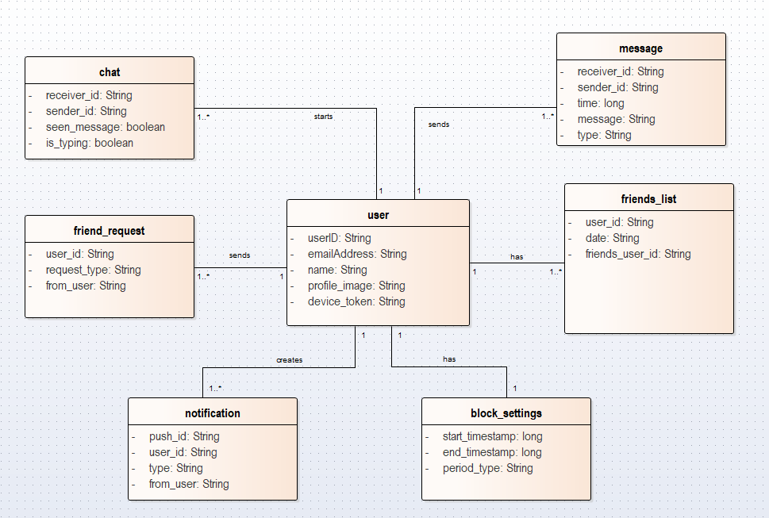

**Figure 4.3.1 Class Diagram of the messaging app**

### Requirement

The requirements of the project will be divided into functional and non-functional requirements.

#### Functional Requirements

The messaging app should able to perform send and receive messages function. It includes text, image, voice and video messages. Auto blocking of incoming notification must be implemented to the messaging app to block incoming messages automatically after the setting is done by the user. The user must be able to customize the setting for auto blocking.

Previous messages should be deleted automatically according to the setting. User can set messages to be deleted by daily, weekly, monthly or by custom date. The messages that marked as important will not be removed automatically unless it is deleted by user manually.

#### Non-Functional Requirements

The app will be developed by using React Native to gain stability and cross-platform development at the same time. The performance of the messaging app must be fast in order to meet the instant send and receive of messages. The security level of the app must be high in order to secure the privacy of the users.

### Project Prototype

****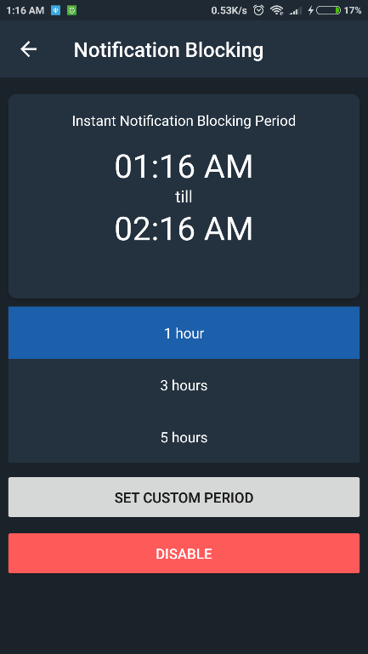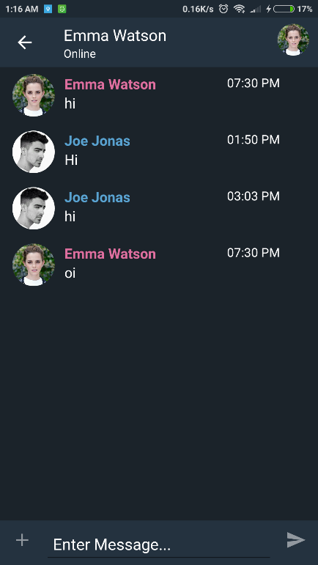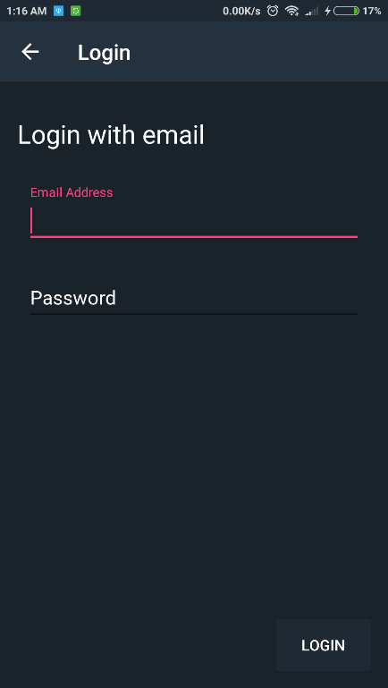

**Figure 4.5.4 Message Deletion Activity**

**Figure 4.5.3 Notification Blocking Activity**

**Figure 4.5.2 Chat Activity**

**Figure 4.5.1 Login Activity**

Figure 4.5.1 is a simple login user interface for user to login to their account with email, phone number, or username. It allows user to retrieve forgotten password with email address.

Figure 4.5.2 is a sample of chatting interface of the messaging app, the left-side conversation indicates the receiver messages and the right-side conversation indicates the sender messages.

Figure 4.5.3 is a user interface to let users set the auto blocking time or period and Figure 4.5.4 is the interface to customize message deletion to work automatically.

# CHAPTER 5

## PROGRAM VERIFICATION

### 5.1 Testing

Mobile app testing is a collection of activities that similar with software testing in order to uncover as many errors as possible to improve customer satisfactions. The test will start from creating test cases of the mobile app, performing UAT and finally the device testing stage.

In this project, the testing project will be carried out by the app author. The test will be performed are listed below:

|  |  |
| --- | --- |
| **Testing stages** | **Description** |
| Content Testing | To test and verify the content of the app to ensure the visibility of the content is suitable for the users |
| Interface Testing | To test the verify the interface to the app in order to ensure it is easy to manipulate by the user. |
| Component Testing | The test and verify each component of the app to prevent bugs like app crashing. |
| Configuration Testing | To test and verify the app on different brand and screen size of android device to ensure that the app is able to perform well in different device |
| Performance Testing | To test and verify the speed of opening the app to ensure good user experience |
| Security Testing | To test and verify the user information is secure from the database |

**Table 5.1: Testing stages**

### Content Testing

|  |  |  |  |
| --- | --- | --- | --- |
| **Test Case:** Application information | | | |
| **Description:** To verify the adequacy of application information to the user in order to let user to have clear understanding on how to use the app. | | | |
| **Step No.** | **Step Description** | **Result** | **Step taken** |
| 1 | Find a user to test out the app without any help of user manual and guide. | Notification Blocking activity has confused the user on how to perform the function. | Pop-out a help manual to guide user to complete the function |

**Table 5.2: Content Testing for App**

|  |  |  |  |
| --- | --- | --- | --- |
| **Test Case:** Inconsistent of title | | | |
| **Description:** The title of activities is not consistent and it confuse the user when using it. | | | |
| **Step No..** | **Step Description** | **Result** | **Step taken** |
| 1 | Tap on the menu button, the “All User” option in drop-down bar is different with its activity | It will confuse user whether they have tap on the correct option | Change the name of activity to the name in the drop-down option |

**Table 5.3: Content Testing for App**

### Interface Testing

|  |  |  |  |
| --- | --- | --- | --- |
| **Test Case:** Text Visibility | | | |
| **Description:** To enhance the text to ensure that user can be easily recognize and read. | | | |
| **Step No.** | **Step Description** | **Result** | **Step taken** |
| 1 | User’s Name doesn’t bold and the thickness of text is same with message description | It used up a little time for user to differentiate the user’s display name and message text | Bold the user’s display name |

**Table 5.4: Interface Testing for App**

|  |  |  |  |
| --- | --- | --- | --- |
| **Test Case:** Size of icon | | | |
| **Description:** The size of icon does not fit different size of phone. | | | |
| **Step No.** | **Step Description** | **Result** | **Step taken** |
| 1 | Check the of size of the icon for auto message deletion and auto blocking of notification is too big for a small size phone screen that below 5 inches | It affected the beauty of user interface and looked like a low-quality product | Use constraint layout instead of relative layout in android. |

**Table 5.5: Interface Testing for App**

|  |  |  |  |
| --- | --- | --- | --- |
| **Test Case:** Blank Chat Fragment | | | |
| **Description:** The Chat Fragment is blank when there is no conversation created. | | | |
| **Step No.** | **Step Description** | **Result** | **Step taken** |
| 1 | Find a user to test it out in order to find out whether the user knows the purpose of the Chat Fragment | The user doesn’t know what the purpose of Chat Fragment is. | Add a line of text in the center of Chat Fragment to let the user know how to add conversation. |

**Table 5.6: Interface Testing for App**

### Component Testing

|  |  |  |  |  |
| --- | --- | --- | --- | --- |
| **Test Case:** Testing on auto message deletion | | | | |
| **Description:** To test and ensure message will be deleted by following the preset time. | | | | |
| **Step No.** | **Step Description** | **Expected Result** | **Actual Result** | **Conclusion** |
| 1 | Test the auto message deletion button to ensure that the destination activity is correct. | The button navigates to Message deletion page | The button navigates to Message deletion page | The auto message deletion button is working fine as expected. |
| 2 | Test the radio button option “Daily”, “Weekly”, “Monthly”, and “Yearly”. | The button selected and saved, and all the deletion can be performed well. | The button selected and saved, and all the deletion can be performed well. | The radio button is working correctly. |
| 3 | Test “Disable” button | The button navigates back to the main activity, and the icon of auto message deletion will become red color to indicate the function is disabled | The button navigates back to the main activity, and the icon of auto message deletion is becoming red color to indicate the function is disabled | The disable button is working correctly as expected. |

**Table 5.7: Component Testing for App**

|  |  |  |  |  |
| --- | --- | --- | --- | --- |
| **Test Case:** Testing on auto blocking of notification | | | | |
| **Description:** To test and ensure message will be deleted by following the pre-set time. | | | | |
| **Step No.** | **Step Description** | **Expected Result** | **Actual Result** | **Conclusion** |
| 1 | Test the auto notification blocking button to ensure that the destination activity is correct. | The button will navigate to the notification blocking activity | The button navigates to the notification blocking activity | The auto notification blocking button is working fine as expected. |
| 2 | Test the radio button option “1 hour”, “3 hours”, and “5 hours” | The button will be selected and saved into the phone preference and performed notification blocking | The button is selected and saved into the phone preference and performed notification blocking | The radio button is working correctly. |
| 3 | Test “Set Custom Period” Button | A time picker dialog will pop-out and prompt user to select the start time and end time. The blocking period will be shown. | A time picker dialog is pop-out and prompt user to select the start time and end time. The blocking period will be shown. | The “Set Custom Period” button is working correctly. |
| 4 | Test “Disable” Button | The button navigates back to the main activity, and the icon of auto notification blocking will become red color to indicate the function is disabled | The button navigates back to the main activity, and the icon of auto notification blocking is becoming red color to indicate the function is disabled | The “Disable” button is working correctly |

**Table 5.8: Component Testing for App**

|  |  |  |  |  |
| --- | --- | --- | --- | --- |
| **Test Case:** Testing on chat components on Main Activity | | | | |
| **Description:** To test and ensure every chat function is working correctly. | | | | |
| **Step No.** | **Step Description** | **Expected Result** | **Actual Result** | **Conclusion** |
| 1 | Tap on the chat user to open profile and send message | A dialog box will pop-out with option of “Open Profile” and “Send message”. The “Open “Profile” option will navigate to user profile activity whereas the “Send message” option will navigate to a chat conversation activity. | A dialog box will pop-out with option of “Open Profile” and “Send message”. The “Open “Profile” option will navigate to user profile activity whereas the “Send message” option is navigate to a chat conversation activity. | The dialog box options are working correctly. |
| 2 | Menu button | A dialog box will pop-out with 3 options, “Account Settings”, “Global Users”, and “Logout” | A dialog box is pop-out with 3 options, “Account Settings”, “Global Users”, and “Logout” | The dialog box is working correctly. |
| 3 | Account Settings (From Menu button) | The option will navigate to user’s account settings activity | The option is navigated to user’s account settings activity | The “Account Settings” option is working correctly |
| 4 | Global Users (From Menu button) | The option will navigate to global users activity, and show all user of the app | The option is navigated to global users activity, and showed all user of the app | The “Global Users” option is working correctly |
| 5 | Logout (From Menu button) | The user will logout from firebase account and it will navigate to Login activity | The user is logout from firebase account and it is navigate to Login activity | The “Logout” option is working correctly |

**Table 5.9: Component Testing for App**

### Configuration Testing

|  |  |  |  |
| --- | --- | --- | --- |
| **Test Case:** Test the app across different phone | | | |
| **Description:** To test the app content whether it is suitable for viewing by the user | | | |
| **No.** | **Phone Brand / Screen Size** | **Result** | **Step taken** |
| 1 | Xiaomi Redmi Note 2 / 5.5 inches | The size of text and icon is suitable for the phone | N/A |
| 2 | Xiaomi Redmi 1S / 4.7 inches | The size of text and icon is a little bit small but the content is still legible for the phone | N/A |
| 3 | Samsung Galaxy S3 Mini / 4 inches | The size of text and icon is small but the content is still legible for the phone | N/A |

**Table 5.10: Configuration Testing for App**

### Performance Testing

|  |  |  |  |  |
| --- | --- | --- | --- | --- |
| **Test Case:** Test the app startup speed and the transition speed between activities | | | | |
| **Description:** To test and ensure every chat function is working correctly. | | | | |
| **Step No.** | **Initial Activity** | **Destination Activity** | **Time taken** | **Conclusion** |
| 1 | Launcher Activity | Main Activity | 2.7 seconds | The time taken is acceptable |
| 2 | Gorilla Fragment (Main Activity) | Auto Message Deletion Activity | 0.8 second | The time taken is acceptable |
| 3 | Gorilla Fragment (Main Activity) | Auto Notification Blocking Activity | 0.8 second | The time taken is acceptable |
| 4 | Chat Fragment  (Main Activity) | Chat Activity | 1.0 second | The time taken is acceptable |
| 5 | Main Activity | Account Settings Activity | 0.6 second | The time taken is acceptable |
| 6 | Main Activity | User Activity | 0.7 second | The time taken is acceptable |
| 7 | Main Activity | Login Activity | 0.5 second | The time taken is acceptable |
| 8 | Login Activity | Main Activity | 2.5 seconds | The time taken is acceptable |

**Table 5.11: Performance Testing for App**

### Security Testing

|  |  |  |  |  |
| --- | --- | --- | --- | --- |
| **Test Case:** Testing on user authentication | | | | |
| **Description:** To test and ensure the user must enter the correct information to access their account | | | | |
| **Step No.** | **Step Description** | **Expected Result** | **Actual Result** | **Conclusion** |
| 1 | Login with incorrect username but correct password | User will be not able to login | User is unable to login | The authentication is working correctly. |
| 2 | Login with correct username but incorrect password | User will be not able to login | User is unable to login | The authentication is working correctly. |

**Table 5.12: Security Testing for App**

### Bug Reporting

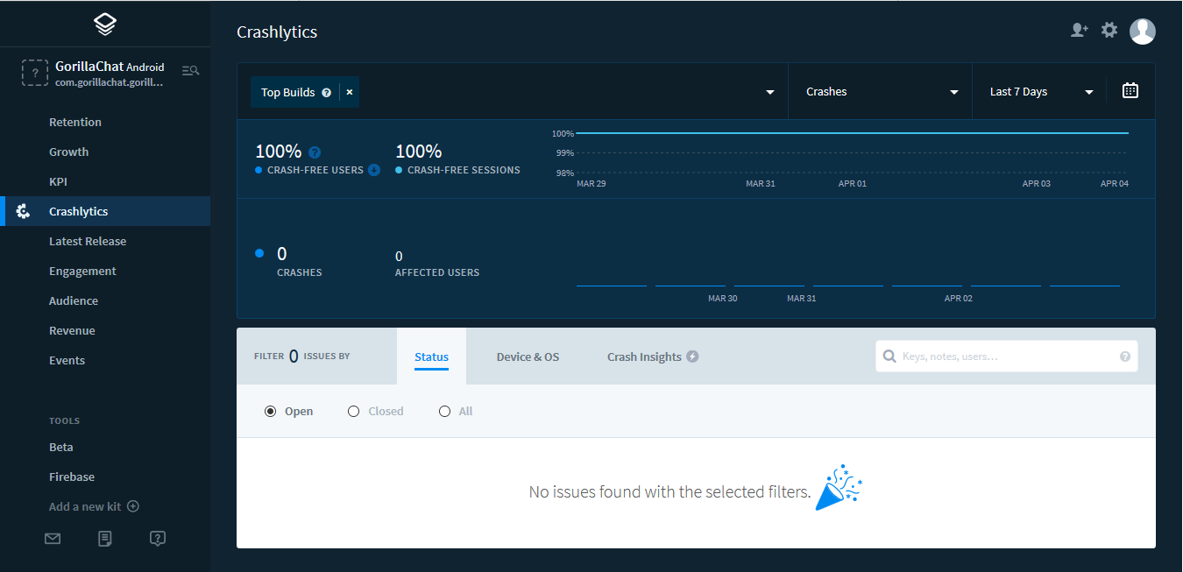

**Figure 5.8.1 Crashlytic bug reporting**

The messaging app will be implemented with a crash report plugin to ensure the app is free from crash and improve user experience.

# CHAPTER 6

## SYSTEM RESULT AND FUNCTIONALITY

### Introduction

In this section, the mobile app interface and the features will be shown. All the interface of the mobile app will be explained step by step on how to manipulate the function of the app. Beside the interface, the database of the mobile app will also be shown.

### 6.2 System Interface

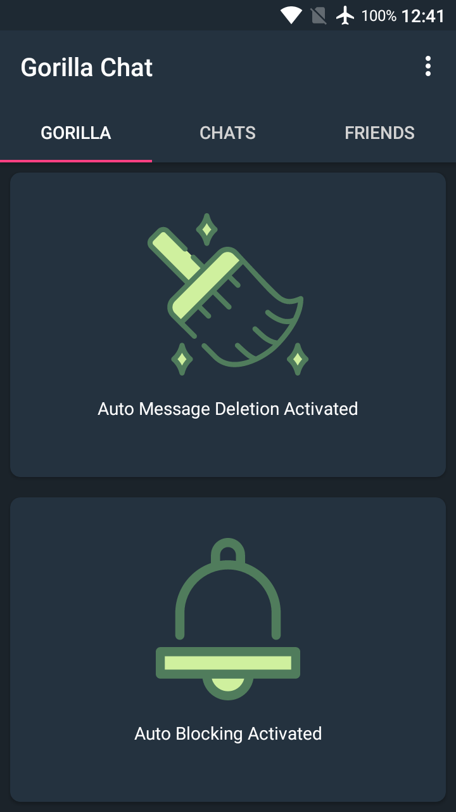

**Figure 6.1 Interface of Auto Blocking and History Deletion**

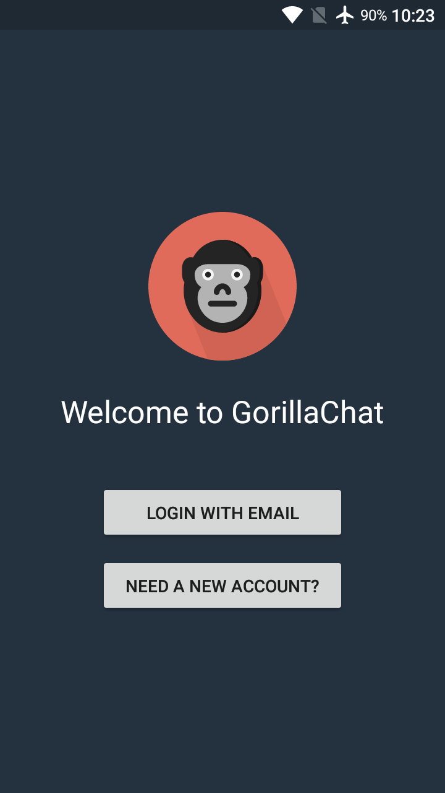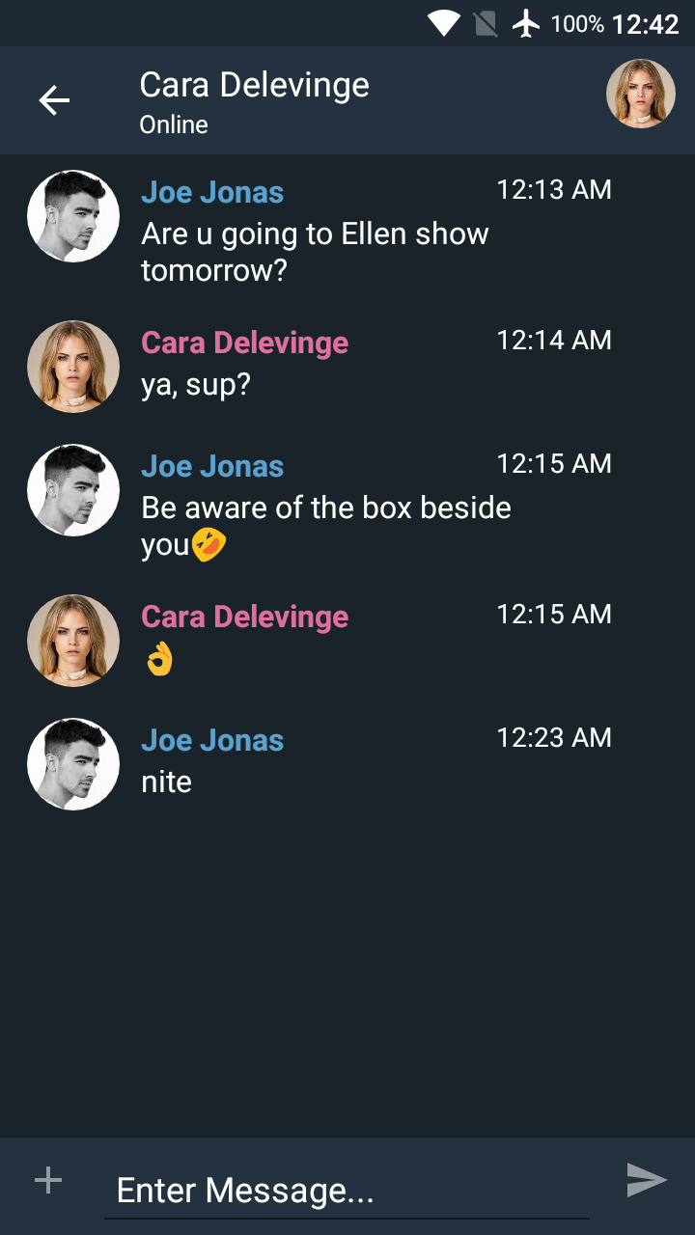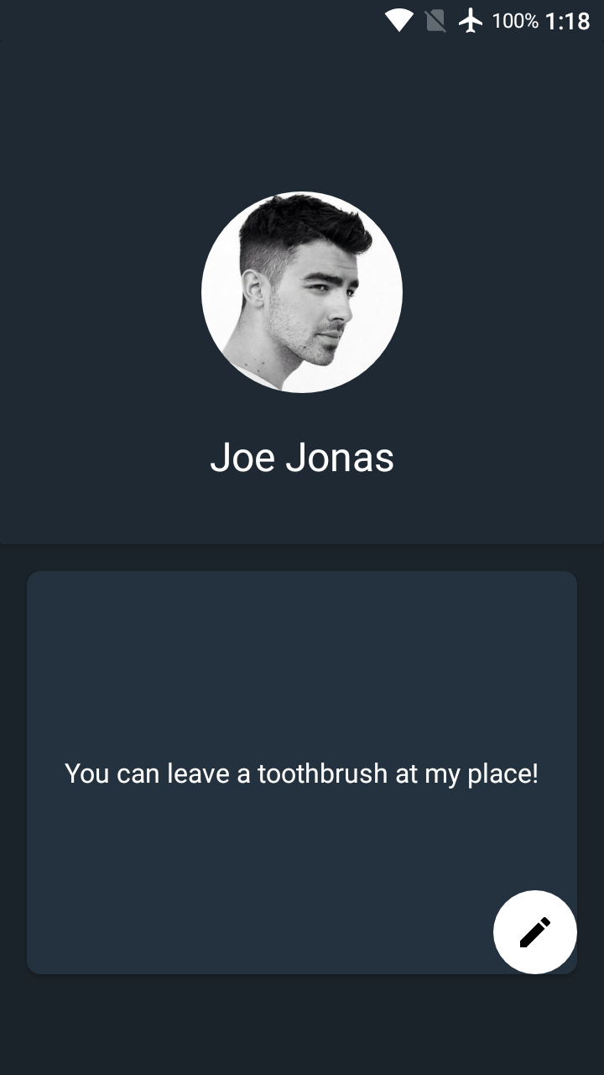

**Figure 6.2 Interface of Profile, Conversation, Register and Login**

### 6.3 System demonstration

The demonstration will be having on 2 mobile devices for sending and receiving the messages.

#### Register and Login

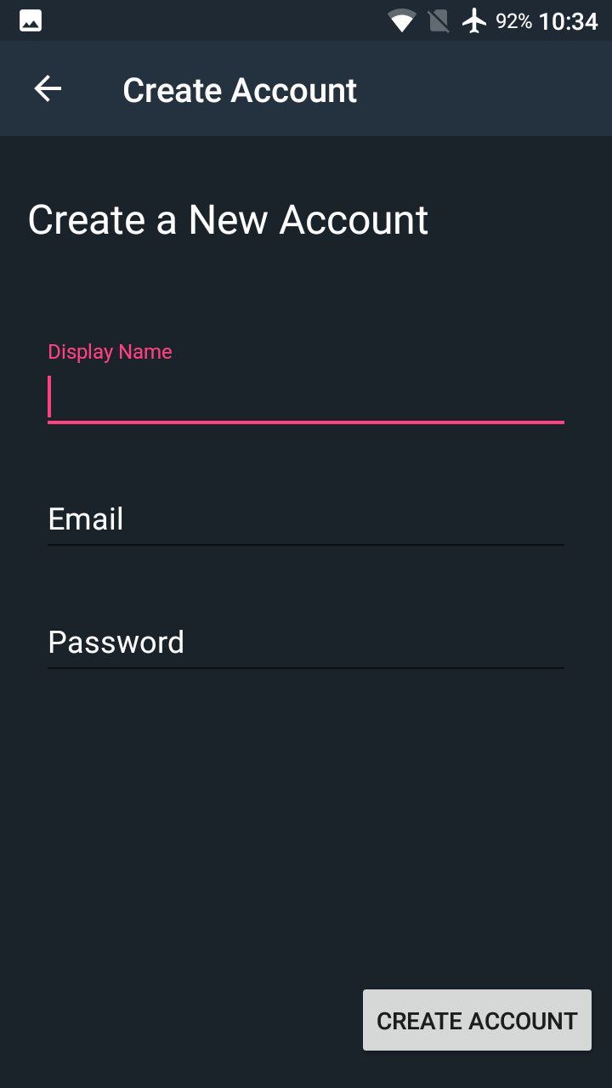

**Figure 6.3.1.3 Processing Registration**

**Figure 6.3.1.2 Register Activity**

**Figure 6.3.1.1 Welcome activity**

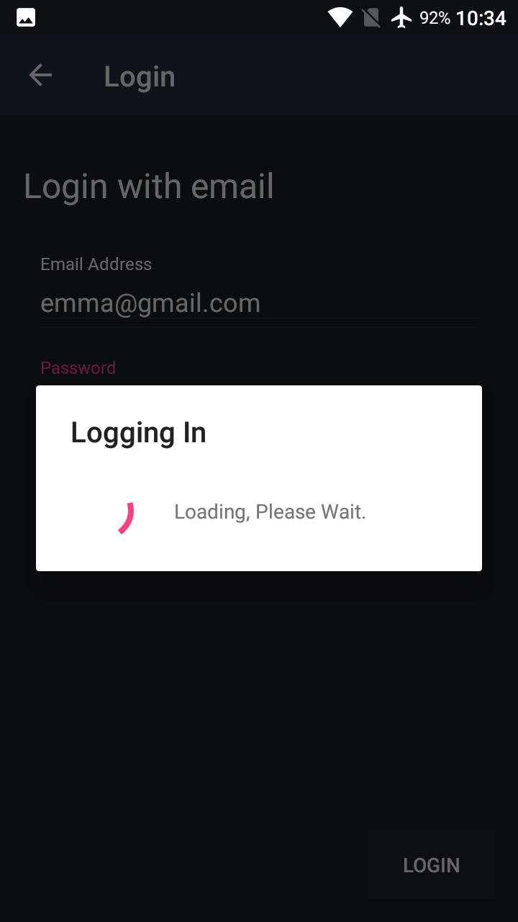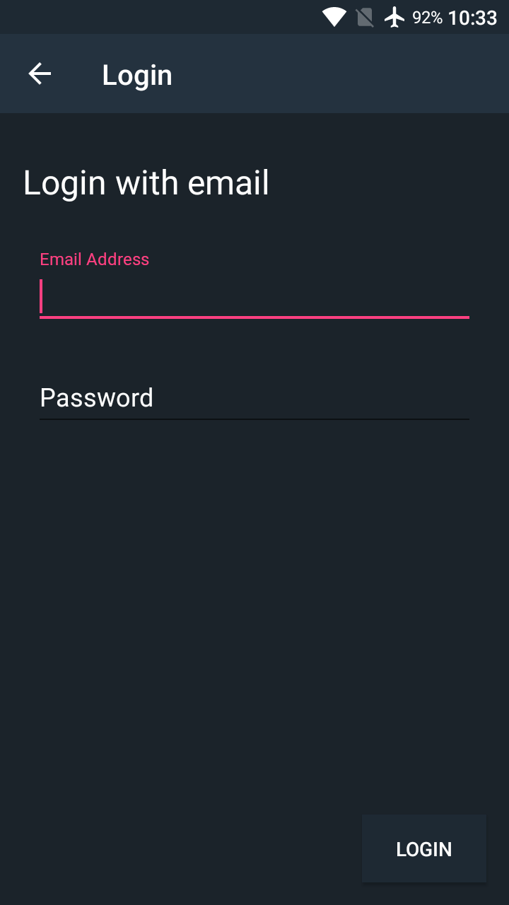

**Figure 6.3.1.5 Login Process**

**Figure 6.3.1.4 Login activity**

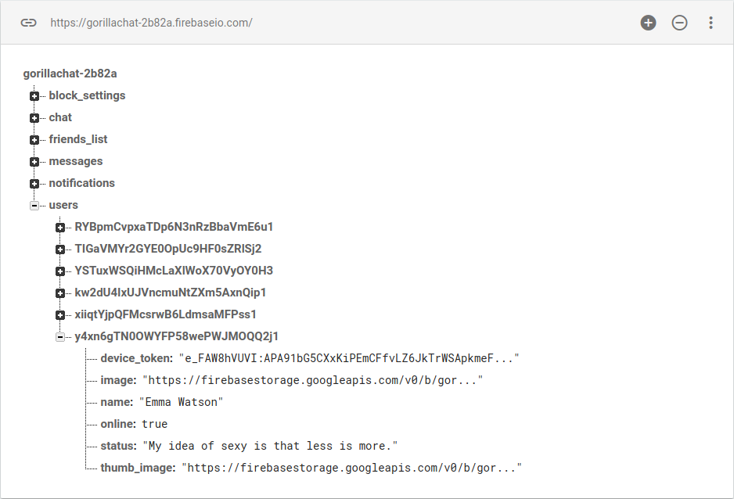

**Figure 6.3.1.6 New user added in Firebase**

**For registration of new user**

The user need to tap on “NEED A NEW ACCOUNT” button to navigate to the registration activity and fill in all the columns that needed, which are the display name, email, and password. Then the user tapped on the “CREATE ACCOUNT” button to create their own account. An alert dialog will pop-out while the user information is sending to the server. In Firebase, the user information will be recorded.

**For user to login**

The user need to tap on “LOGIN WITH EMAIL” button to navigate to the login activity and fill in all the columns that needed, which are email and password in order to login their account. Then the user tapped on “LOGIN” button and an alert dialog will pop-out while the authentication process is going on. If the user’s email and password is correct, user is able to login to their account.

**6.3.2 Send and Accept Friend’s request**

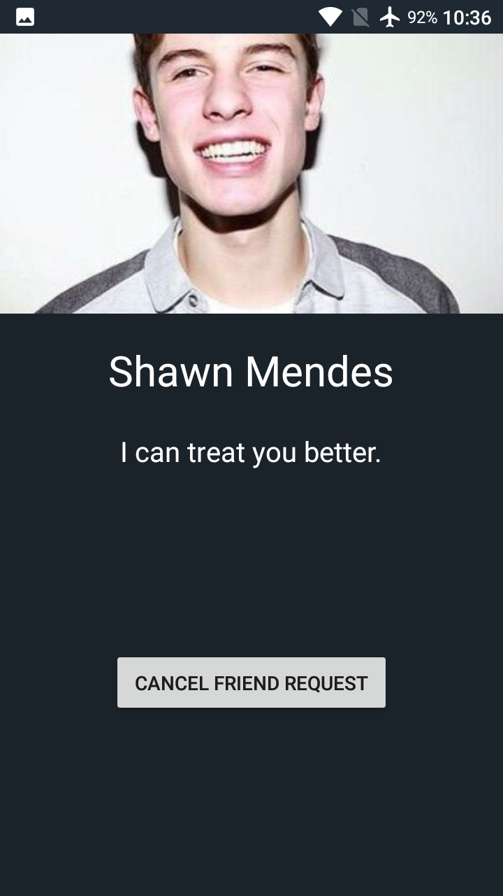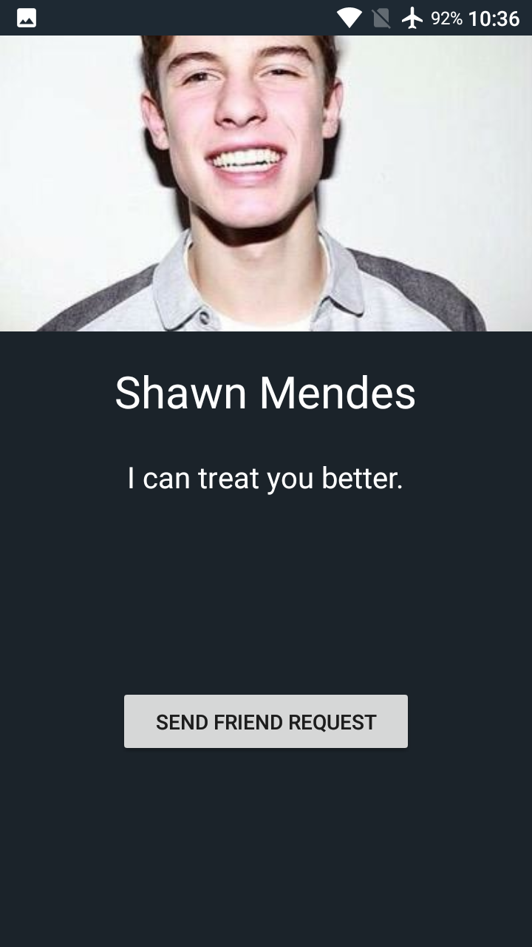

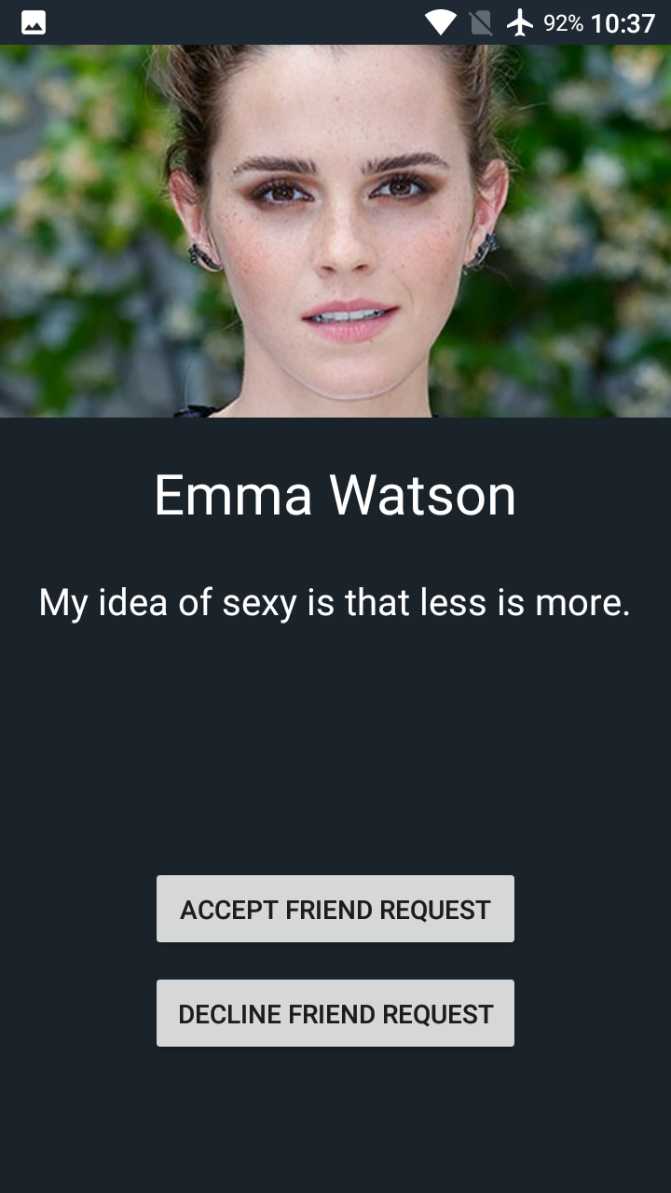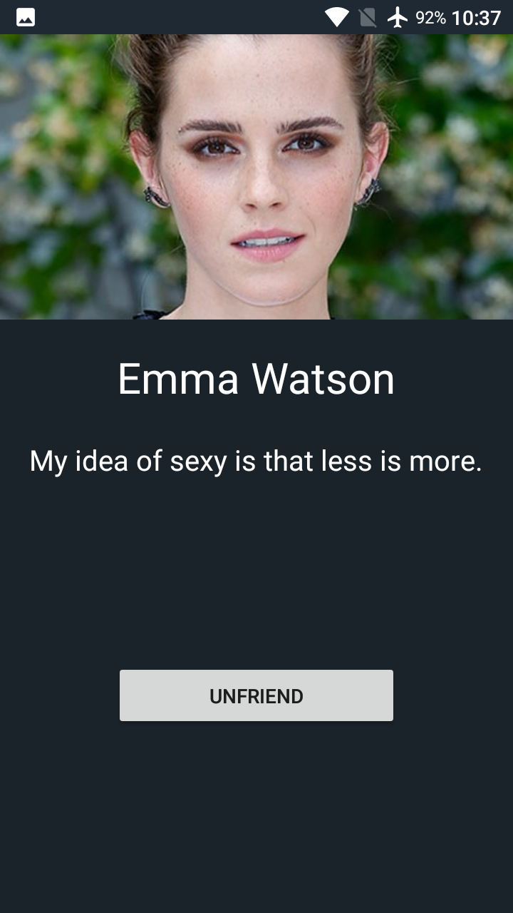

**Figure 6.3.2.2**

**Cancel Friend Request**

**Figure 6.3.2.1**

**Send Friend Request**

**Figure 6.3.2.4**

**Unfriend**

**Figure 6.3.2.3**

**Accept/Decline Friend Request**

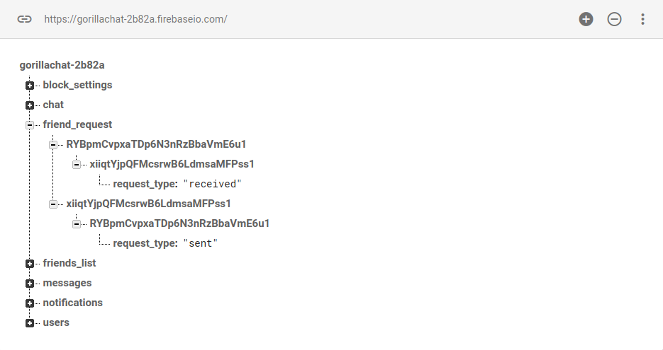**Figure 6.3.2.5 Friend request is created in Firebase**

When the user need to add friend, he or she need to tap on the “SEND FRIEND REQUEST” button to perform the action. The “SEND FRIEND REQUEST” button will turn to “CANCEL FRIEND REQUEST” after the friend request was sent and the record was created on the database.

The person that received the friend request is able to perform 2 actions which are accept or decline friend request. It the “ACCEPT FRIEND REQUEST” button is tapped, the ‘ACCEPT FRIEND REQUEST” button will turn into “UNFRIEND” button, it is used to remove the friendship in the future.

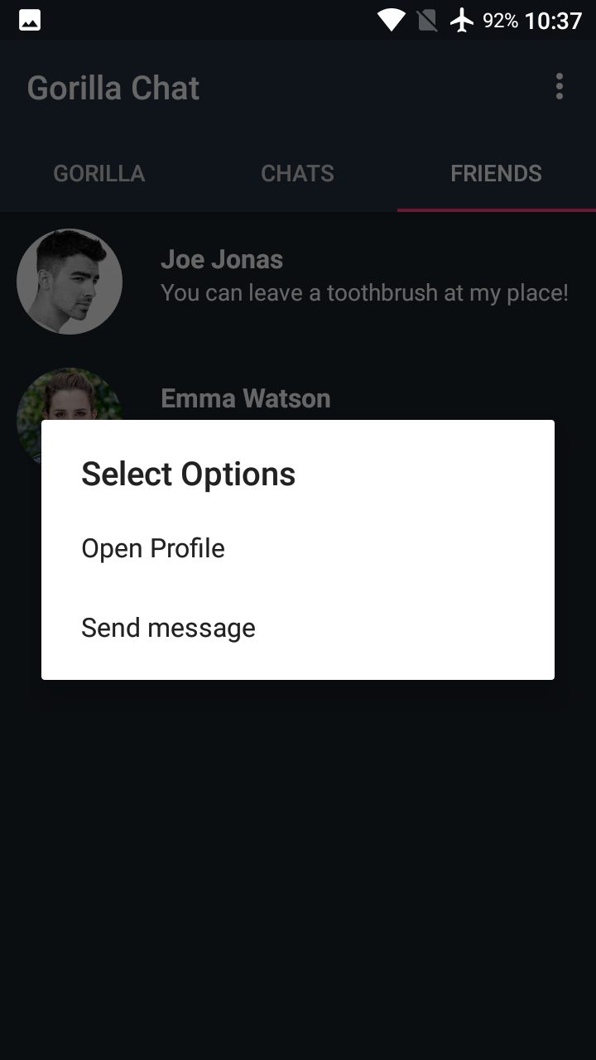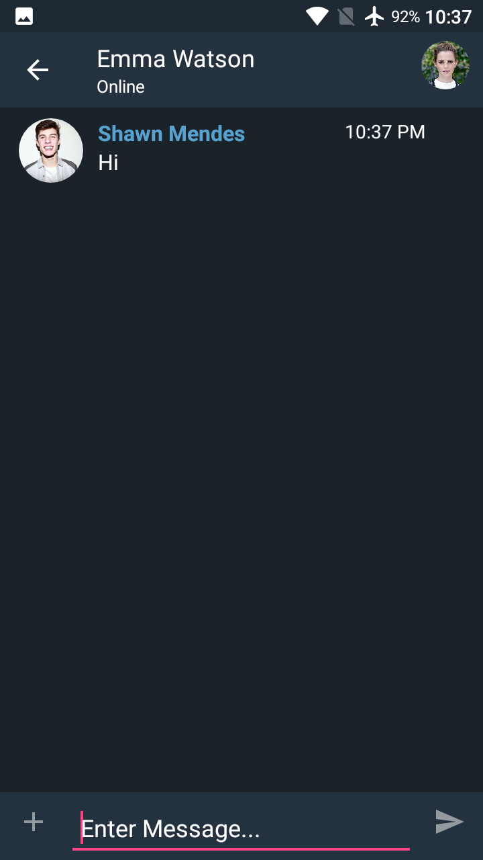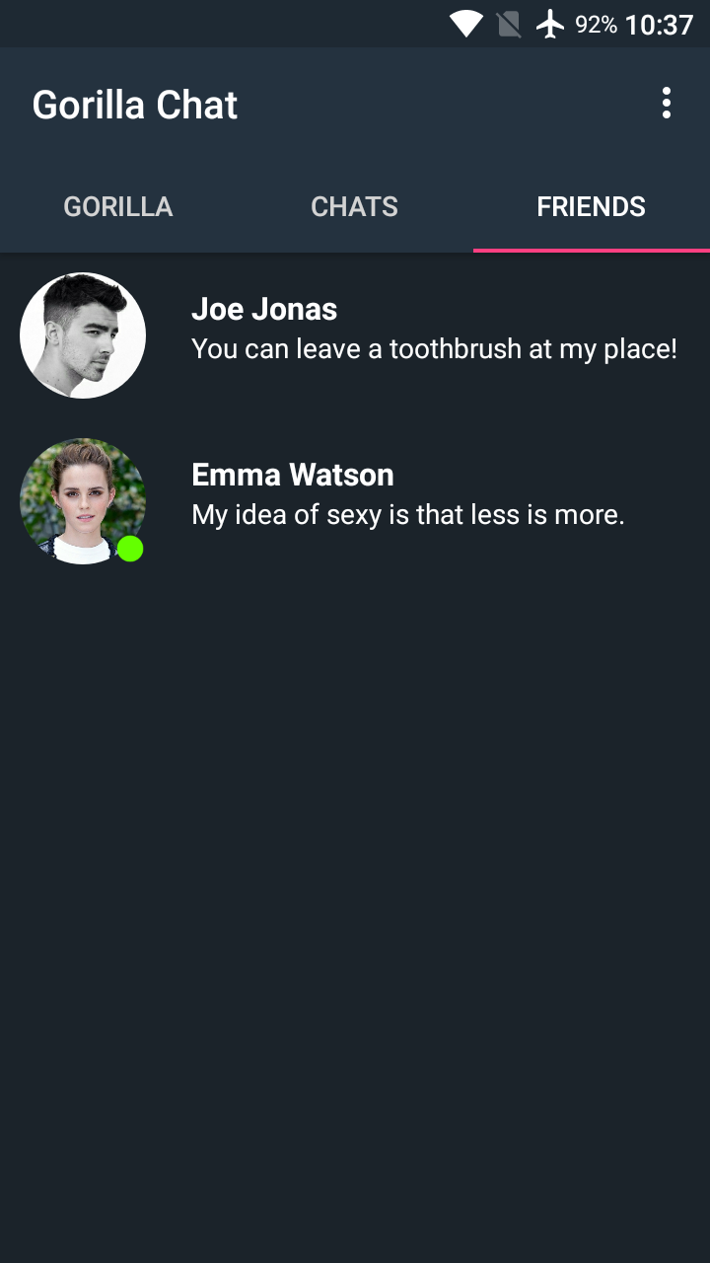**6.3.3 Start a conversation**

**Figure 6.3.3.3 Chat Activity**

**Figure 6.3.3.2 Dialog Options**

**Figure 6.3.3.1 Friends Fragment**

To start a new conversation, the user need to navigate to the “FRIENDS” tab, and tap on a friend, a dialog will pop-out to prompt the user for the next move. To check the profile, the user can tap on “Open Profile” option. To proceed on to a new conversation, user need to choose the “Send message” option. Then it will navigate to the chat activity, user can enter the message and send it to their friends.

**6.3.4 Auto Message Deletion**

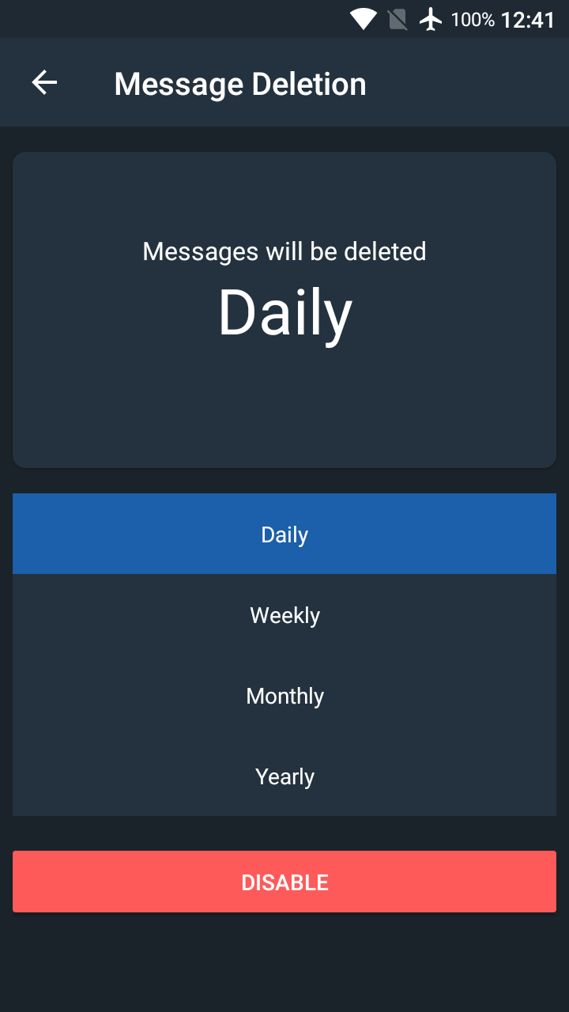

**Figure 6.3.4.2 Message Deletion Activity**

**Figure 6.3.4.1 Gorilla Fragment**

It is easy to perform the auto message deletion function, user need to choose the first option with a broom icon from the “GORILLA” tab, then it will navigate to the “Message Deletion” activity. The system allow user to choose the message deletion frequency by daily, weekly, monthly, and yearly. After choosing, the option will be saved. To disable the function, user just need to tap on the disable button.

**6.3.5 Auto Notification Blocking**

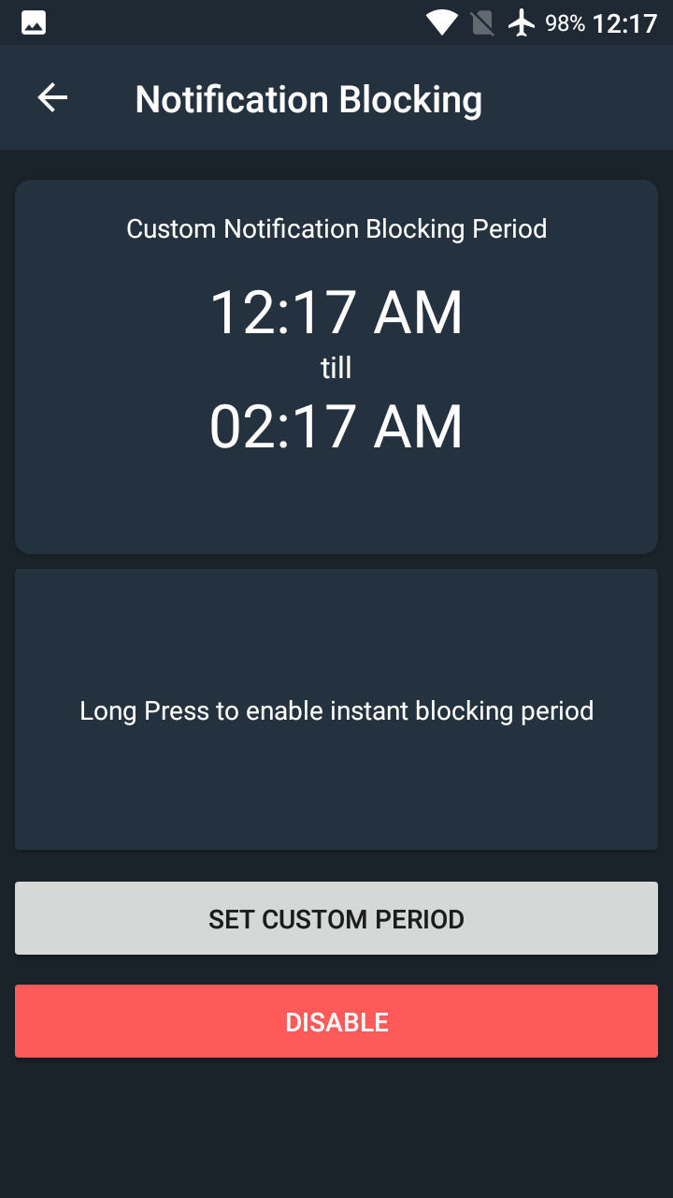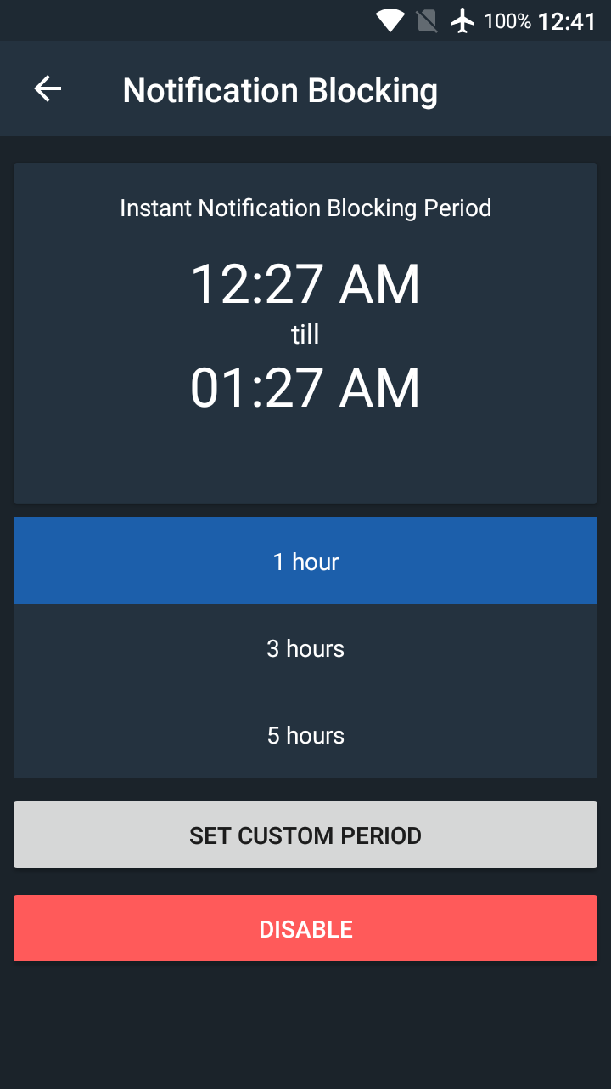

**Figure 6.3.5.3 Custom Blocking Period**

**Figure 6.3.5.2 Instant Blocking Period**

**Figure 6.3.5.1 Gorilla Fragment**

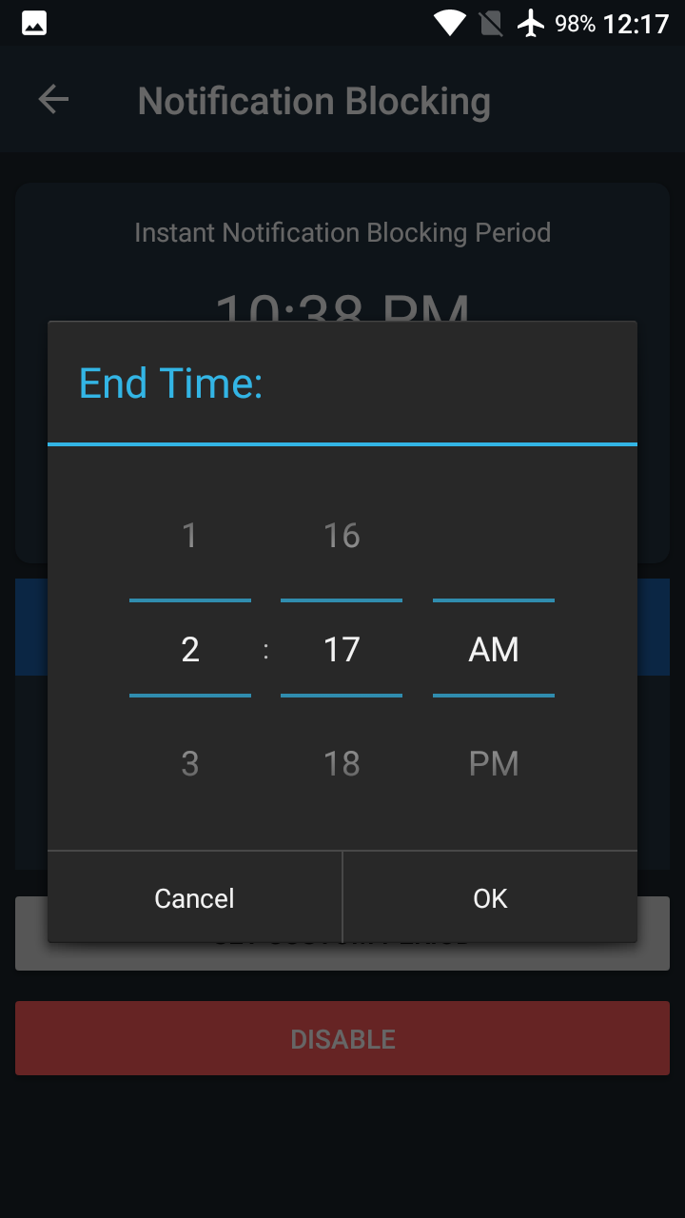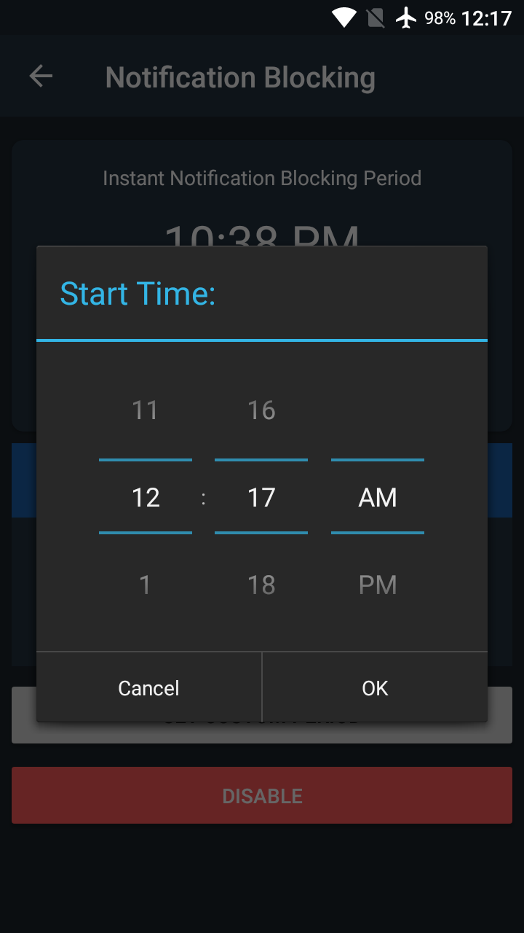

**Figure 6.3.5.5 Set End Time**

**Figure 6.3.5.4 Set Start Time**

To perform auto notification blocking, the user need to choose the option with a bell icon on the “GORILLA” tab, then the notification blocking activity will show the instant notification blocking period in 1 hour by default. User can choose 1 hour, 3 hours, or 5 hours to block the message notification instantly for once. If the user decided to block it every day, the user should tap on “SET CUSTOM PERIOD” button, and a time picker dialog will pop-out and prompt user for the start and end time for the blocking period. After setting, the period will be saved. To switch back to instant block period, user needs to hold on the “Long press to enable instant block period” button. To disable the function, user needs to tap on the “DISABLE” button.

# CHAPTER 7

## CONCLUSION AND RECOMMENDATION

### Conclusion

There are a few of messaging app in the market currently, but it is rare to see the messaging that implemented the auto message deletion function. Most of the messaging app in the market is letting their user to delete chat messages manually, it is considered as time consuming for the process of message deletion. Therefore, to ease user for doing such a repetitive process, the auto message deletion function is implemented to the messaging app. The auto message deletion function can help user to remove their message by daily, weekly, monthly, or yearly. Besides that, the period auto notification blocking function is also able to fully customize by the user. The mobile app user can set the blocking period once and use it until they want to change it.

It is easy to setup a real-time database with Google Firebase for a messaging app. Firebase provides a NoSQL database for storing the data, therefore it is easy to store and access the data in real-time.

### Recommendation

In order to in sync with the technology in the future, the massaging app should implement with block-chain technology in order to increase the security and integrity of massaging data. It can overcome the limitations that related to identity control, eliminates intermediaries and third parties and allows any party involved to send and share value with other elements on the network, and ensuring speed, authenticity and verifiability.

For the automation of the notification blocking and message deletion, it should implement with machine algorithm in the future in order to track user habit and perform the relevant action. The messages also should be backup before the action of message deletion.